ANSDELL & FAIRHAVEN W.I. NEWS
NOVEMBER 2021

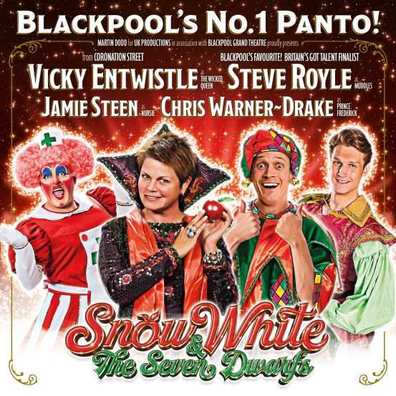

Friday 17th December at 19.00 hours.
For tickets, please contact Janet Carling, our Social Secretary
janet.carling@gmail.com

NOVEMBER A&FWI EVENTS

Tuesday 2nd November @ 14.00 hours
Knit & Natter
Meeting at the Ansdell Institute Café

Tuesday 9th November @ 19.30 hours
W.I. Meeting
Meeting at The White Church, we welcome Graham Stirrup this month to talk about “Women and WW1”.

DOORS OPEN AT 19.15 HOURS

Thursday 18th November @ 10.30 hours
Social Group
Meeting @ Lytham Hall

Tuesday 23rd November @ 13.30 hours
Craft Group
Meeting @ St. Anne’s Parish Church Hall, Headroomgate Road, Lytham St. Anne’s FY8 3BA

Monday 29th November @ 19.00 hours
Book Club
Meeting @ The County Hotel in Lytham
This month’s book is Ragdoll by Daniel Cole

NOVEMBER LFWI EVENTS

Sunday 14th November @ 10.00
Willow Weaving Workshops at the LFWI Offices

Thursday 18th November @ 19.00
Ken Pye – Famous Animals of Merseyside via Zoom

Friday 19th November @ 10.00
Willow Weaving Workshops at the LFWI Offices

Wednesday 24th November @ 10.30 Crazy Golf at The Flower Bowl, Barton Grange

Thursday 25th November @ 19.00
Se7en Brothers Brewery Tour in Salford

Saturday 27th November @ 13.30 Lancashire Day at St Marie’s, Almond Brook Road, Standish, Wigan

to our November babies
Rita Calvert, Muriel Ward,
Valerie McLachlan, Caroline Little, Janet Curran
______________________________________
COVID pending, we are having our Christmas Lunch on Monday 6th December from 12.30 hours at Fairhaven Golf Club again this year. If you would like to join us, please contact our Social Secretary, Janet Carling janet.carling@gmail.com

Fairhaven Golf Club
Christmas Menu 2021

2 Courses £19.95
3 Courses £23.95

Starters
- Broccoli & Stilton Soup OR Forest Mushroom & Tarragon Soup
served with Croutons (V)

- Prawn & Mango Cocktail with Marie Rose Sauce & Rustic Malt Bread

- Coarse Duck & Armagnac Pate with Apple Chutney & Melba Toast

Main Course
- Marinated Salmon Fillet, Benedict Spinach Hollandaise topping

- Roast Fylde Turkey Breast, Bacon & Chipolata Rolls, Sage & Apricot, Sage & Onion stuffing, Cranberry dressing

- Caramelized Roast Onion & Brie Tart with Chilli Infused Rocket Salad (V)

- Herb Crusted Pork Loin with a Bacon & Leek Sauce and Baked Spiced Apple
All Served with Roasted Potatoes and Seasonal Vegetables
Desserts
- Spicy Figgy Christmas Pudding with Brandy Sauce or Brandy Butter
- Festive Crumble, Apple & Mixed Spice Served with Anglaise Sauce
- Fanned Poached Mulled Wine Pear with Calvados Clotted Cream
