**ANSDELL & FAIRHAVEN W.I. NEWS**

**MAY2021**

**www.ansdellwi.weebly.com**

**PRESIDENT’S ADDRESS**

Well, we're here again, living this strange lockdown life, half-in and half-out!  We see the temptation of some freedom ahead, but we're unsure how much we can safely grab.  We are armed with strength and resilience that age and experience brings, but I think we are finding the shifting of the goalposts a bit tiresome.

What we need to do is to keep reminding ourselves that amid the continuing uncertainty there is much to be hopeful about, a glass half full perhaps.  I for one took the first step recently and enjoyed a *full* glass of Guinness (the iron is good for me) with the right amount of people, socially distanced, in Lytham Square.  Laughter and chatting about nothing in particular was a joy and will hopefully be continued regularly, with the additional bonus of being allowed indoors from the middle of May.

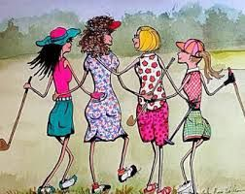Life brings us as many joyful moments as it does downfalls, and although there are days when we wish there was a manual to follow, it simply wouldn't be the same without some "spontaneity".  Let's start doing some things out of a natural impulse, not over-thinking it.   A pat on the back for the physical, mental and emotional struggles encountered during this pandemic, and how those challenges were handled.  What about joining our intrepid walkers (see details below) sometime in May for a walk for however long you wish, book a table inside or outside a restaurant and contact other members to join you, a game of crazy golf perhaps or a picnic in the park to discuss that book everyone is reading at the moment.

Let's remember that it will not be this way forever - it is a difficult time, but it is just that - a time.  Thinking of you all,

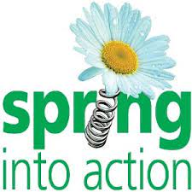**MAY MEETING**

On Tuesday May 11th at 7.30pm our Zoom presenter is Jacqueline Iddeson. In her presentation “Spring into Action” she’ll be showing us the different areas of her beautiful garden and telling us about the plants she grows in her nursery, plus a little about the garden sculptures her husband creates.

Susan will send you the link as usual, please do try to join us.

**ANOTHER MEETING IN MAY!**

Make sure you read the back page to find out about another sort of meeting in May!!!

**WALKING IN MAY**

You may remember an email Susan sent on 18th April about our intrepid members, Rita and Janet, walking 50 miles in May. Attached to the email today is a form for those of you who want to join them for this fundraising event or to make a much needed donation to their worthy charity, The Samaritans.

Keeping checking your emails for the dates and times when Rita and Janet are walking as you may wish to join them.  Remember all those lovely walks that we used to do together!  Hopefully we can rekindle our love of walking as a group - socially distanced of course and maybe stop for a cuppa afterwards.

**MAY BIRTHDAYS**



Wishing our May birthday members

a very Happy Birthday

Anne Allingham

Evelyn Davidson

Mai Golightly

Pat Costello

Bette Nichols

**EASTER MEMORIES**

**A family tradition from Bette Nichols**

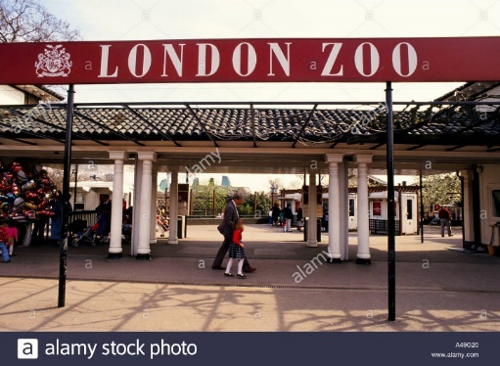When I was a little girl it was our family tradition that on Good Friday my parents would pack up a picnic which included a large supply of hot cross buns and we would get on the train from Romford in Essex to the London Zoo.

There is one particular occasion when I was about 6 years old which really sticks in my mind for a number of reasons. Health and Safety was not much of an issue in those days and you could get very close to the animals and even feed them.

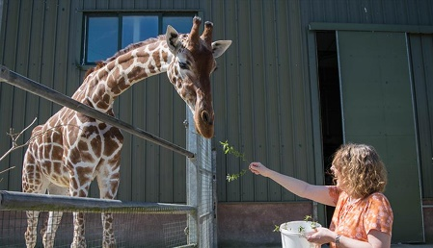My Dad would take great delight in feeding hot cross buns to the elephants. 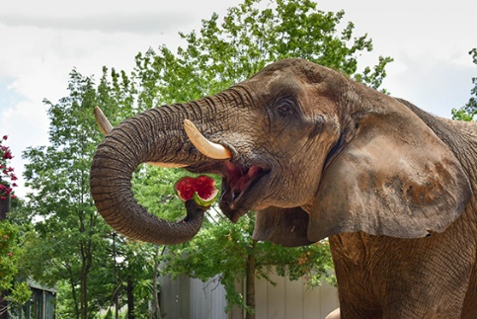He would throw a hot cross bun, the elephant would pick it up in its trunk and put it in its mouth and we all used to clap. Of course you wouldn’t even get close enough to do that now but I also seem to remember him feeding a giraffe similarly. I have a memory of my Dad with his back turned from the Giraffe enclosure and the Giraffe bending its neck and almost reaching my Dad’s shoulder I assume hoping for more buns.

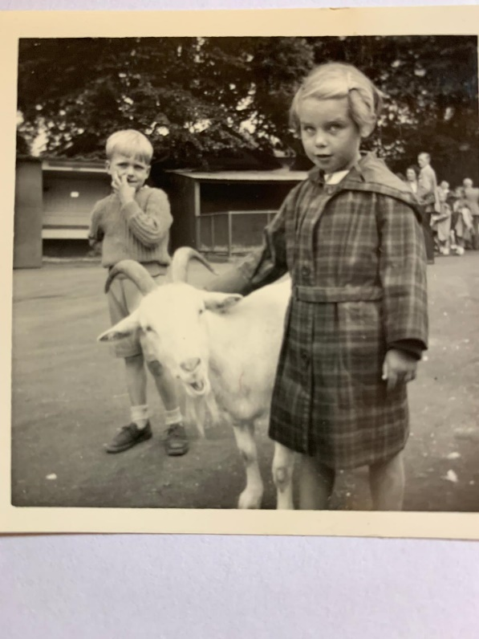This photograph reminds me of the part of the day when we would go to the Children’s Zoo Section where you could walk around amongst the animals and pet them.

On this occasion my Dad was wearing a light coloured rubberised material mac which seemed to have strips of the same material which held the seams together from the inside with some kind of glue and if he got warm the mac would start to fall apart. This must have been one of those days as I can remember the grown-ups laughing and saying he was falling apart at the seams.  He obviously loved this mac as he would always be repairing it. We are talking early to mid-1950s here!!

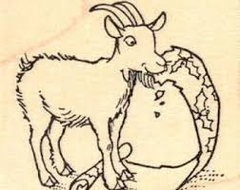 I remember my Dad letting out a yelp because he felt something inside his mac. It turned out to be the goat in the picture chewing at one of the seam strips which must have been hanging down. He didn’t feel it at first as it started at the end of the strip and worked its way up inside.

The whole family were in absolute hysterics because he couldn’t get the goat to stop so he had to rip off the strip of material so it could eat the rest. Then it kept following us hoping for more. I am not sure if the photo of was taken before or after the incident or even if it is the same goat but it does bring back many happy memories of the regular once a year trip we all made to London Zoo every Good Friday. Needless to say after the goat incident my Dad decided to buy a new mac.

**Dorothy Williams has memories of a traditional family Easter**

My earliest memories of Easter go back to childhood when it was a big family celebration.

Preparing for Easter was such fun

. 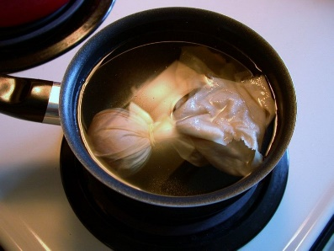

My mother boiled eggs in onion skins to colour them golden and my two younger sisters and I painted faces and patterns on others.

We arranged them in little straw baskets to be carried on our Easter parade.

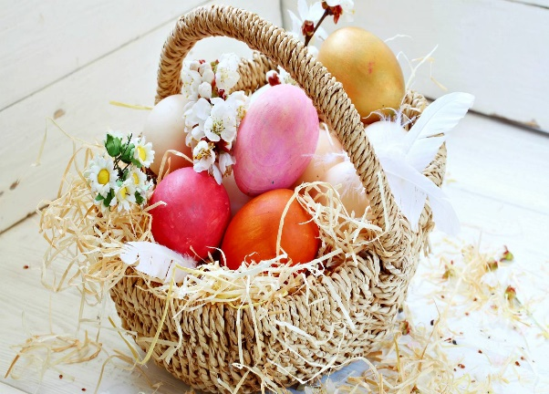

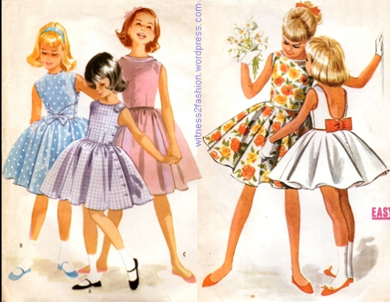

On Easter Sunday we went to church; my sisters and I wearing new Easter outfits, dresses made by my mother, white socks and sandals and bows in our hair.

The most exciting day was Easter Monday when we walked from Penwortham and across the river to Avenham Park, Preston. This is a beautiful Victorian park on the banks of the Ribble and the ancient Easter egg rolling ceremony has been held there for over 150 years, originally symbolising the rolling of the stone from Christ’s tomb.

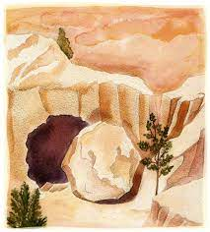

There we met up with our family and friends – Grandma, Grandad, aunties, uncles and cousins   We competed with each other by rolling eggs and trying not to break them too soon and then playing games and having a picnic.  This was a yearly tradition and some of the friends in our group weren’t local and I can only remember ever seeing them at this occasion.

Of course in my memory the park was always crowded, the weather was always beautiful, everyone was happy and there was loads of fun and lots of laughter.

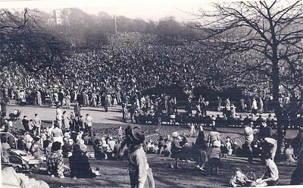

**Glenis’s memory is of a much less traditional family Easter!**

In the 1950s all the talk amongst Burnley children in the days leading up to Easter was not of egg painting, egg rolling or new clothes but – ***“Are you going to see Jack Moore’s monkey?”***

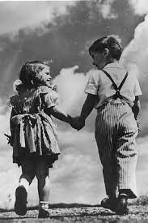Families would pack up a picnic early on Good Friday morning and set off for a long, long walk. Although at that time Burnley was a maze of stone terraced houses wrapped around mill buildings, my family was lucky, our house was in a street alongside a mill but only a hundred yards from open countryside, so on Good Friday we had a very pleasant country walk of over an hour

The walk ended by going over a canal bridge and into a field, in a place locally called “Pendle Bottoms”! As the photo shows it was many miles from the foot of Pendle Hill, you could see it – just!



The first thing to do of course was to have our picnic, but my brother and I ate very quickly because there were much more exciting things to do! In the bottom corner of the field was a little farm outbuilding, you stepped down into it through a very low doorway where there was a little tea shop with a flag floor. A little old lady, (well she always appeared to be old to us) sold cups of tea, pop and crisps – the sort with little blue bags inside! But what my brother and I really went in for was ice cream! It was made by a local family called Cece, (originally of course from Italy!)

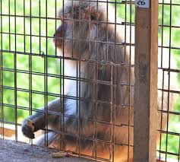As we came out of the building on the other side was what all Burnley children wanted to see - Jack Moore’s monkey! He/she was housed in a little wooden cage. We always tried to get the monkey to come to us and hold on to our fingers, you had high status with the other children if you managed it, I don’t think I ever did!

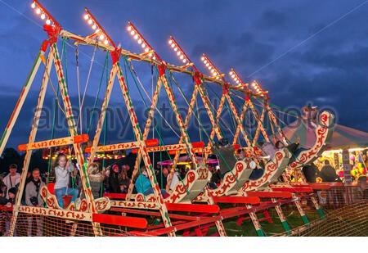Going back up into the field, across in the top left hand corner was my favourite part of this exciting day, Swing Boats! It was quite a battle every year between my brother and I as to who could make it swing highest, I did manage that at times despite the fact that he was a year older!

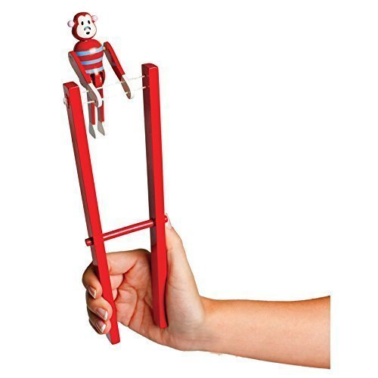Then came the long weary walk home. The first stage of which however was exciting, because alongside the country lane there were stalls selling a range of cheap toys – bows and arrows, bead threading, cork “pop” guns skipping ropes and monkeys on sticks. Choosing was always difficult, as was obeying the instruction not to use the toy until we got home – this, of course, was to encourage us to walk more quickly!

Just as Dorothy says on the previous page, on this day *“the weather was always beautiful, everyone was happy and there was loads of fun and lots of laughter”.*

**WHAT MY GARDEN MEANS TO ME**

Rita Calvert tells us just what her garden means to her

My garden is a place to escape to.

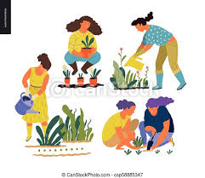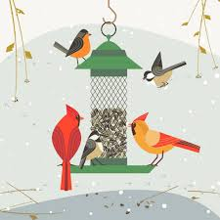 A place for physical exercise- weeding, planting, cutting and dead heading.

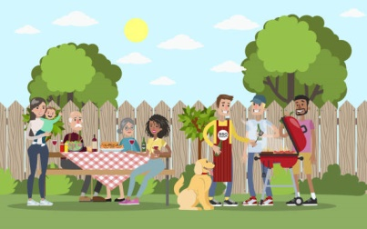A place to watch and listen to the visiting birds.

A place to welcome friends back to after a long absence.

A place to observe the changing seasons-

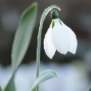

the first snowdrop,

the first unfurling of fresh green leaves on the trees,

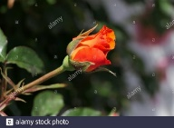the first rose

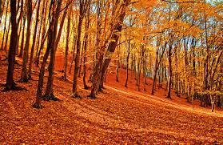

and the arrival of autumn.

**I couldn’t be without my garden.**

Joan Shaw’s garden gives her a connection with the seasons too

One of the most important things my garden gives to me is a connection to the seasons.

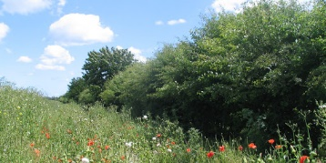For many years I lived in the countryside surrounded by fields, hedges and trees.  It was one big garden and you only had to step outside and breathe the air to know what time of year it was and feel the changes of the seasons week by week.

Living here, and especially by the coast, the seasons are not so obvious and I miss that connection.  My garden helps to compensate.  There is a rhythm to all the necessary jobs associated with the different times of the year and the garden is very different in each season.

In Winter it is quite bare,

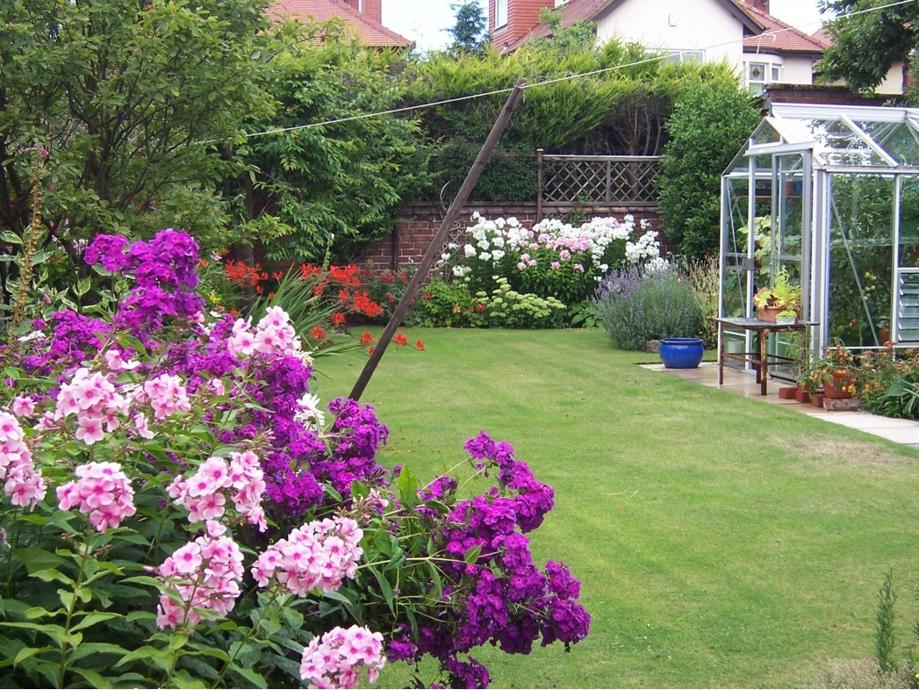

Spring brings slow new growth with lots of promise.

By Summer it is a riot of colour …

and in Autumn it slowly slips into seed heads and decay.

It all gives a seasonal rhythm which is endlessly satisfying and enjoyable.

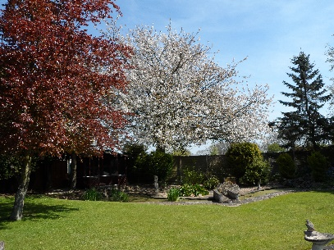**Rita Kendrew has special memories of this garden.**

It was where she lived before moving here, how beautiful it was.

**Susan Brierley visited a garden which she recommends as a place to admire and enjoy**

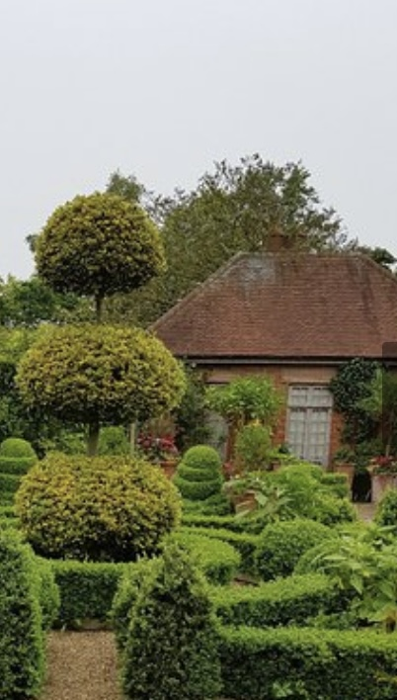

We have just returned from a wonderful week in Norfolk visiting our son and family. He took us to East Ruston Gardens - an amazing jewel in Norfolk’s crown- near Norwich.

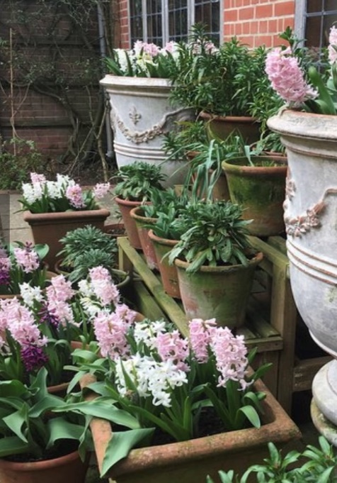

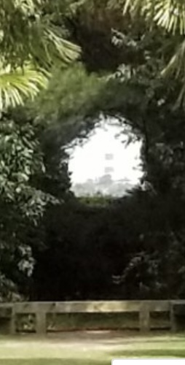

The gardens have been built from a totally blank canvas by 2 inspirational men who designed & maintain this privately owned garden entirely by themselves

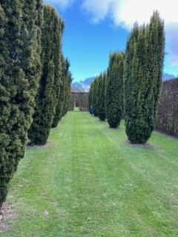

.

There are a great variety of separate gardens eg Rose, Exotic, Woodland, Mediterranean, Vegetable & many more. All are linked cleverly together

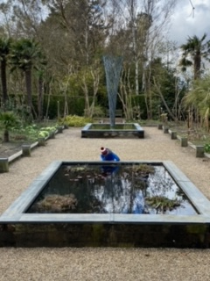

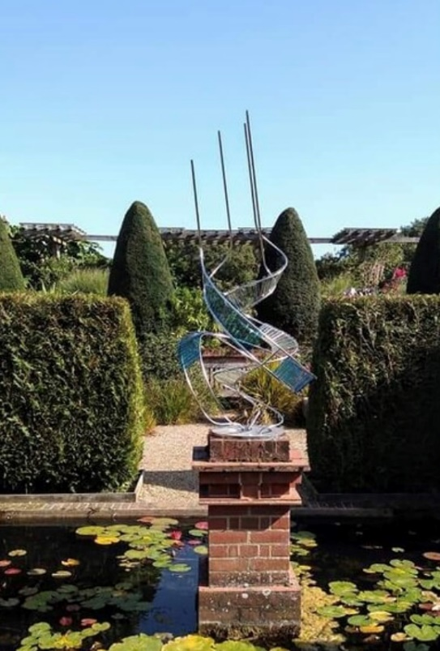

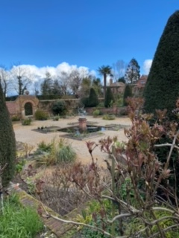

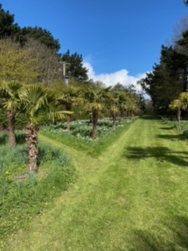

An excellent garden to admire & enjoy plus a highly recommended tearoom but unfortunately closed during our visit.

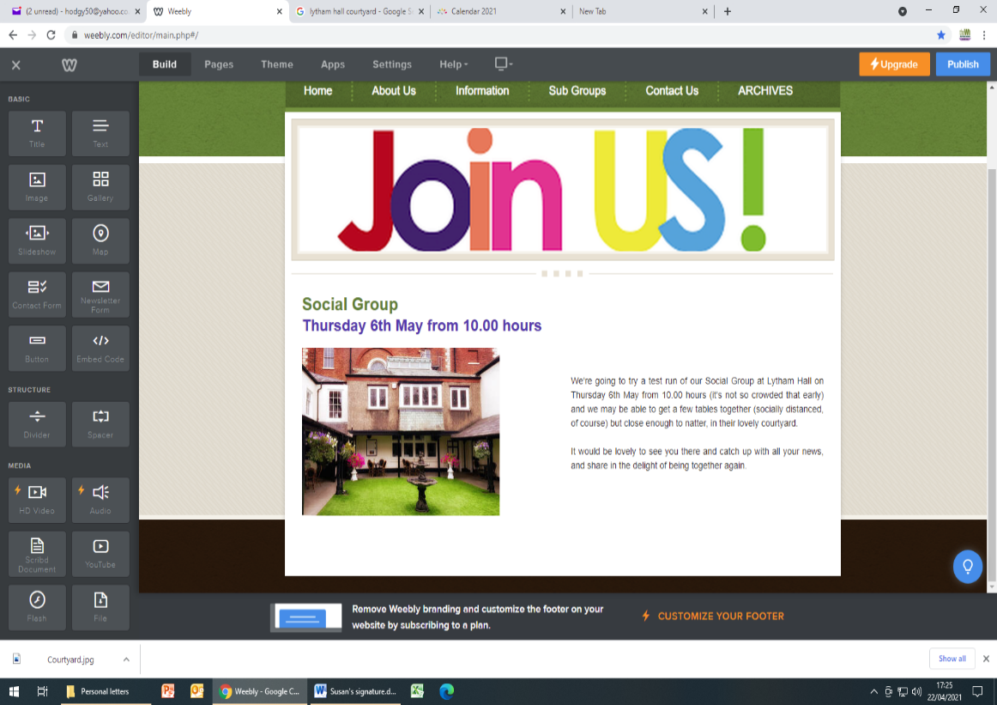

**ON THURSDAY 6TH MAY**

**FROM 10AM**

**SOCIAL GROUP**

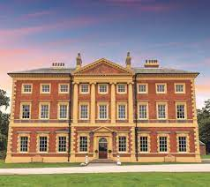

**We’re going to try a test run of our Social Group at Lytham Hall on Thursday 6th May from 10am. It’s not so crowded early and we hope to be able to get a few tables near together, socially distanced of course, but close enough to natter in their lovely courtyard.**

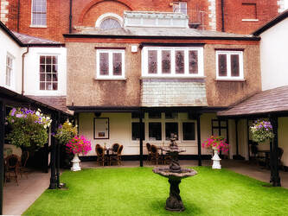

**It would be lovely to see you there and catch up with all your news, and share in the delight of being together again.**

## Online events – May 2021

Wednesday 5th - Paul Robbins,

Great British Eccentrics 7pm

Thursday 6th – Mark Frances, Sewing Bee 7pm

Saturday 8th – Joady Grime, the Fondant Pig 2pm

Monday 10th – Technology Surgery 6.30pm – FREE*

Tuesday 11th – Flower Wreath, Claire Salmon 2pm

Wednesday 12th – Jenny Mallin, Grandmothers Recipe Book 7pm

Thursday 13th – MCS Workshop – FREE* 6.30pm

Saturday 15th – Debbie Bradley, More Family Tree research 2pm

Thursday 20th – Richard Rickett, Honeybees (2nd Talk) 7pm

Saturday 22nd – MCS Workshop - FREE* 10.00am

Monday 24th – Steve Hill MBE, Adventurer and Fundraiser 2pm

Wednesday 26th – Mary Macintyre, Astronomy 7pm

Thursday 27th – David Hastings, Heroes at Sea (RNLI) 7pm

Saturday 29th – Lindsey Barrell, HYGGE 2pm

Full details on all these online events will be available a week before each event on our Website and Facebook and will be emailed to all WI Officers. You will be able to book them on the Online store at **www.lancashirewi.org.uk****.**

**All events are priced at £5.00\***

**Please feel free to pass this information to friends and family as these events are open to non-members**

**Please note you do not need to have a PayPal Account to make the purchase, just follow the instructions on the LFWI payment page**