**ANSDELL & FAIRHAVEN W.I. NEWS**

**MARCH 2021**

**www.ansdellwi.weebly.com**

**A MESSAGE FROM THE PRESIDENT**

I have always marvelled at the ability some people have to say something profound in just a few words and I’ve found myself looking up the quotes and using them in my daily life. Last year I saw a list of “*12 daily reminders*” which have been very helpful to me and I would like to share a few of them with you. My hope is that as you read over some of these you will feel be inspired to use them into your daily life too.

Firstly, (1) *the past cannot be changed,* seems wholeheartedly pertinent right now followed by (2) *everyone’s journey is different,* and we all know that (3) *happiness is found within!*  Everyone is encouraging us to smile as (4) *smiles are contagious,* and the one that has been truly relevant to everyone most especially this year is (5) *kindness is free.* I have lived by the premise that (6) *positive thoughts create positive things,* but it has been difficult in these recent times to find those positive thoughts when life has been a constant struggle.

But now the journey really begins! The changes in the lockdown rules and life seemingly soon to become “normal” again! It is totally understandable that recent events have dented our confidence and left us feeling reluctant to push outside our comfort zone. But together, we can help each other to build a different and brighter future, a time to look forward and try new challenges, both personally and together with our friends at the W.I.

Thinking of you all,



 **MARCH**

Thank you so much for your contributions to the newsletter. The themes have resulted in your contributions being full of personal memories and I am very grateful to you for sharing them with us. I am sure everyone will enjoy reading them.

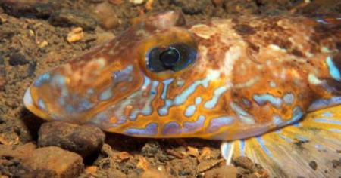Our next Zoom meeting is on Tuesday 9th March and, **please note at an earlier time of 7pm.** Our speaker is Gordon Fletcher, who some of you will remember from when he spoke to us in 2019 on the topic, Morecambe Bay, Underwater Safari. This time his topic is “From Sculpture to Marine Art Works, which sounds very intriguing!

So look out for an email from Susan with a link to the Zoom meeting – **on Tuesday 9th March at 7pm.** Just click on the blue text and wait up to about a minute and then the Zoom meeting will start to open for you.

**MARCH BIRTHDAYS**

Happy Birthday to all our March babies, hope you have a lovey Birthday cake!

Maureen Crawford

Diane Lee

Barbara Dobson

Sheila Jose

Anna Ross

Carol Pallister

Dorothy Iddeson

Susan Hodgson

A FAVOURITE PHOTO

We start our photos in Lytham on a beautiful sunny day

**Pat has sent this one which some of you will recognise**

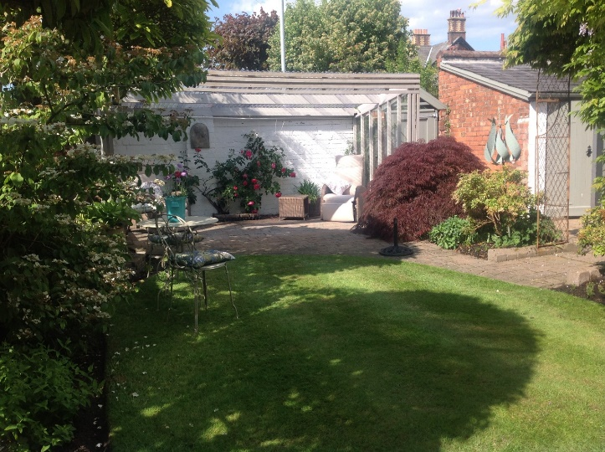

My Arbour in Lytham, where I had many cups of coffee and long chats with my WI friends.  Treasured memories.

**Dorothy Barrett’s photo is also of Lytham, but in very different weather -**

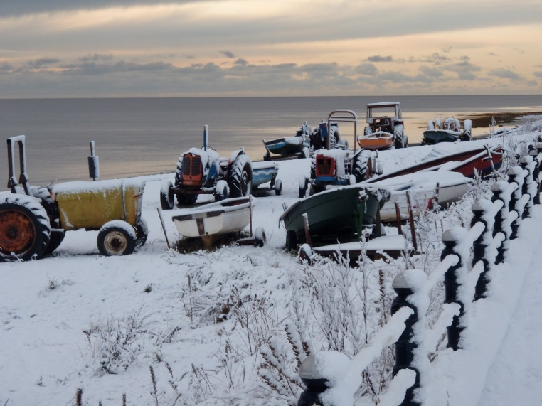

Dorothy says -  A photo taken of the tractors on Lytham beach during a winter a few years ago.  I love the brightness of the tractors against the snow and dark sky.

Now we cross the Atlantic to visit Nasa

**Lorraine has lots of favourite photos but has sent us an unusual one, she says -**



I like taking unusual photographs, this is one of them, it's blown up on my dining room wall.

One of the most interesting places I've been is NASA, I took this in one of the huge hangars, hanging from the roof is an Apollo rocket, these are a shot of the engines. A constant reminder of a superb day!

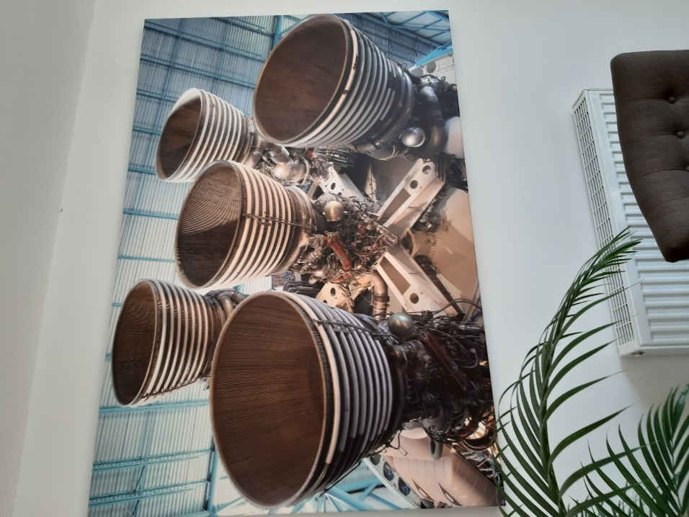

**Back to the UK, another photo from Pat, she says -**

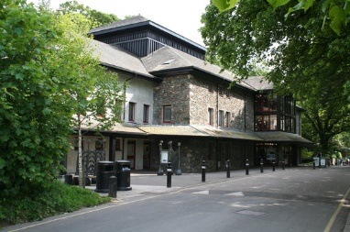Dorothy and I loved our trips with the Ashton theatre group and especially Keswick’s Little Theatre

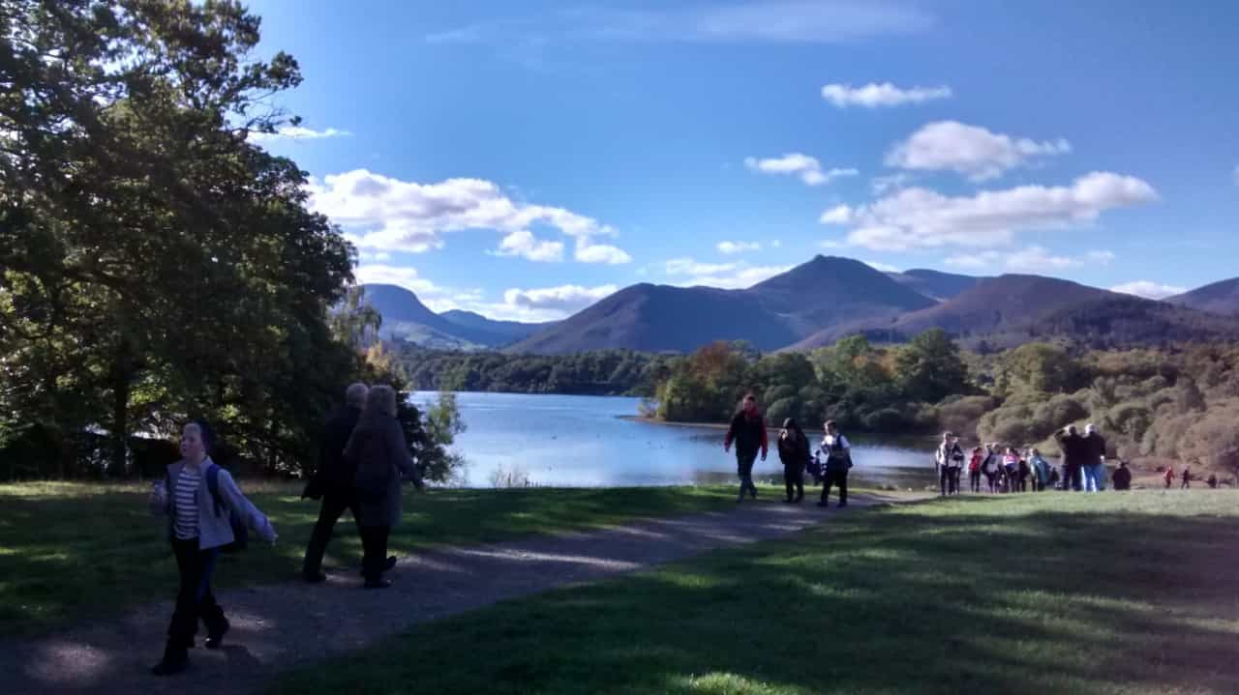

We always seemed lucky to have good weather in Keswick and this was a most beautiful clear day, Derwent water with Catbells in the background.  Can’t be beaten. Wonderful day.   Sorry I can’t remember the play, but they were always excellent. Such good times.

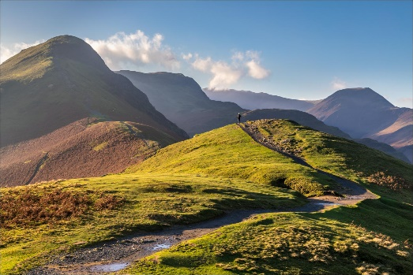

I have climbed Catbells, on a very windy day.  Had to come down some of it on my bottom with my three year old daughter clutched around my front. We just couldn’t keep on our feet.

**Then across to the other side of the world with Julie**

I was born and brought up in the industrial North East where holidays were a real luxury.  We spent a fortnight each year visiting YHA hostels. The dream of overseas travel was, just that, a dream.

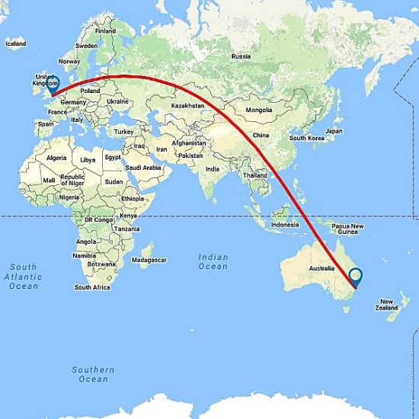

David and I have been very lucky insomuch as since the children left home we have travelled to many countries but never ever thought we would get to Australia, beyond our dreams.

We saved and saved and in 2015 we managed the trip.  When I saw the Opera House I cried.  This was the ultimate destination for me.   I know my parents would have been surprised and thrilled.  Of all the places I have been this left me awestruck.

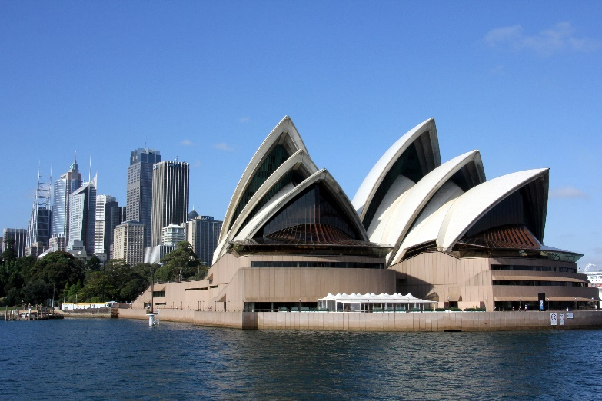

**We are back in Lancashire with Susan Brierley, but she takes us back nearly 500 years, she says -**

Here is my special photo, it is of my husband and me celebrating my 60th birthday. We had the most wonderful time dressing up in Tudor costumes and celebrated in style at Whalley Abbey in the Ribble valley.

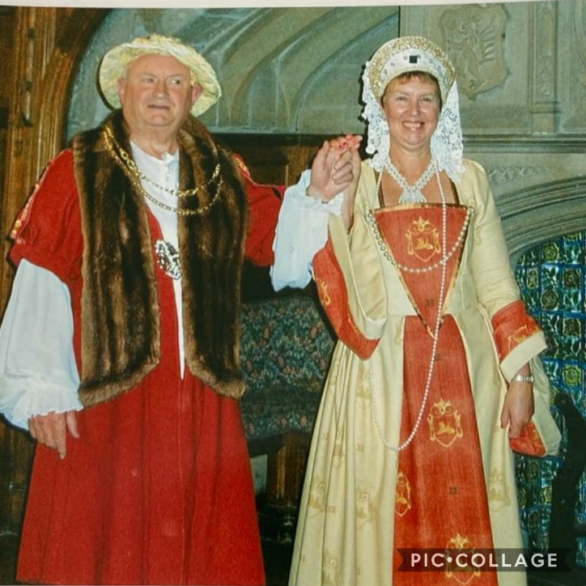

My husband says he deliberately put on extra weight so he’d look more like Henry V111 - a likely story - but being as what happened to two of his wives I wasn’t going to argue.

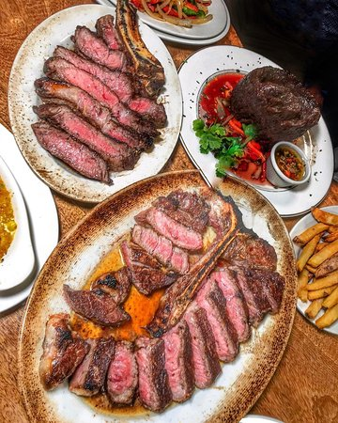

We ate a wonderful dinner of good old English roast beef carved at the table - we did use cutlery though and not our fingers!

In the evening we danced the night away to a very energetic Ceilidh (not the easiest in our dresses) before collapsing into bed in their lovely accommodation.

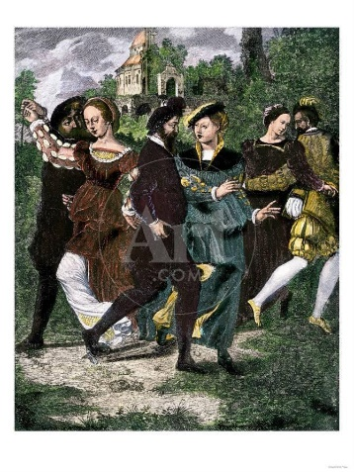

Great fun was had by all. Below is a collage of photos of all the beautiful costumes. I especially love the one of my son pulling up his tights- his expression says it all - “how do you ladies wear these things”.

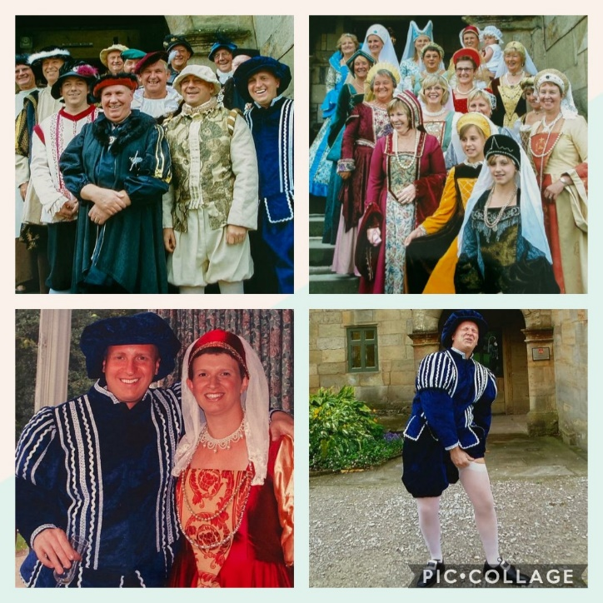

A FAVOURITE POEM OR SONG LYRIC

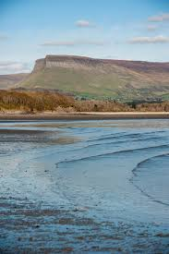**Rita Calvert tells us why she has selected her poems -**

In the summer of 1976 we visited Sligo. We went to the beautiful beach at Lissadell and visited the grave of W. B. Yeats.

I love his poetry and would recommend “ The wild swans at Coole “

The trees are in their autumn beauty,

The woodland paths are dry,

Under the October twilight the water

Mirrors a still sky;

Upon the brimming water among the stones

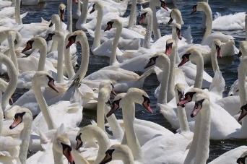Are nine-and-fifty swans.



Another of his poems I really like is

“A prayer for my daughter “

May she become a flourishing hidden tree

That all her thoughts may like the linnet be,

And have no business but dispensing round

Their magnanimities of sound,

Nor but in merriment begin a chase,

Nor but in merriment a quarrel.

O may she live like some green laurel

Rooted in one dear perpetual place

**Lorraine’s reason for liking a song lyric is, like Yeats, connected with her daughter, she says**

This may not be my favourite song but it has lots of happy memories.

In 1971/2 I was expecting my first child and I was desperate for a daughter, we had chosen the name Tracy when we were about 15, so in 1972 a group called The Cuff Links released a single called Tracy, which I played over and over again, singing merrily away doing my housework and dancing too!

Anyway Tracy duly arrived on 7th July 1972 - but I doubt the song was responsible for it!

These are the  lyrics for your entertainment!

Tracy, when I'm with you somethin' you do  
Bounces me off the ceiling  
Tracy, day after day when you're this way  
I get a lovin' feelin'

Come with me don't say "No"  
Hold me close Tracy never let go

Tracy, you're gonna be  
Happy with me  
I'll build a world around you  
Filled with love everywhere  
And when you're there  
You'll be so glad I found you

Come with me, don't say "No"  
Hold me close  
Tracy, never, never, ever let me go

**Joan Shaw shares two of her favourite poems with us**

**‘The Listeners’ by Walter de la Mare**

It begins

‘Is there anybody there?’ said the Traveller,

Knocking on the moonlit door;

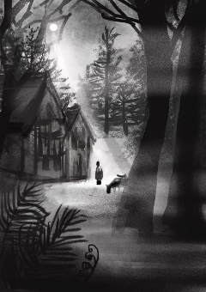And his horse in the silence champed the grasses

Of the forest’s ferny floor;

And ends

Ay, they heard his foot upon the stirrup,

And the sound of iron on stone,

And how the silence surged softly backward,

When the plunging hoofs were gone.

It is full of mystery and suspense, paints a vivid picture and the poetry is beautiful.

The second is **‘The Glory of the Garden’ by Rudyard Kipling.**

As a gardener I find it interesting and it makes me smile.  It is a hymn to gardening and worth looking up.

Our England is a garden, and such gardens are not made

By singing:- ‘Oh, how beautiful!’ and sitting in the shade,

While better men than we go out and start their working lives

At grubbing weeds from gravel-paths with broken dinner knives.

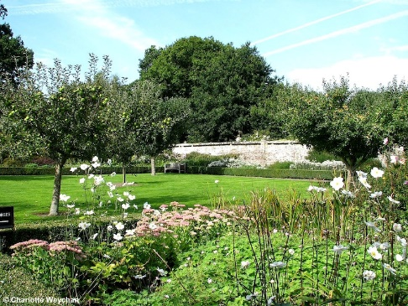

**Tricia shares a poem which states it is a 17th century Nun’s prayer**



Ed and I have kept a copy of the Nun's Poem for many years and feel the advice fits any age group!

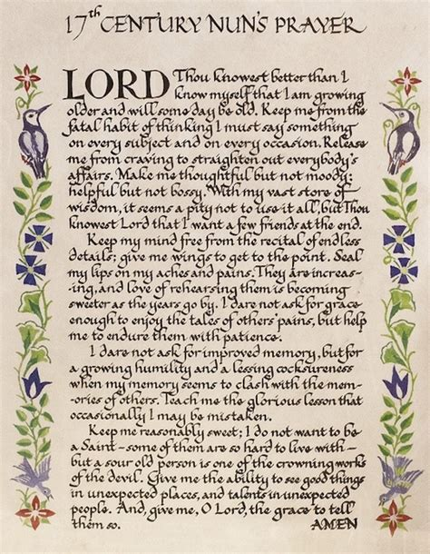

The actual origin of the poem is unknown but is widely acknowledged not to be from the 17th Century and is probably not written by a nun but it is clear it provides good advice to all of us – and with humour.

**Dorothy Williamson explains the reason for her favourite song, she says -**

My Favourite Song is ‘Sailing’ by Rod Stewart, every time I hear the opening line of the song ‘Sailing’ it takes me back to my sailing days. I have had the good fortune to sail from a young age as my father had a boat on Lake Windermere.

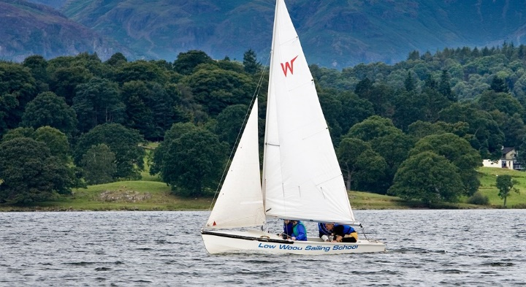

With my late husband, Peter, I have many happy memories of sailing in different countries to include India, North America, the Mediterranean and home waters. My most calming memories are sailing in The Med. from the Costa Brava skimming across clear blue seas by day and a blanket of stars at night only guided by the moon.



Events could however always change pretty quickly at sea and the song line, ‘I am sailing stormy waters’ then become more the case.

My most scary memory was during a lovely fresh wind sail, when we noticed on the horizon cigar shaped clouds indicating a Tramontana Storm was approaching rapidly! The sea swelled and the waves grew high, so it was a terrifying race to drop the sails and batten down the hatches, whilst urgently heading for safe harbour under engine power.

The waves became like mountains, but Peter an experienced sailor, calmly got us to a sheltered cove where we safely dropped anchor and weathered out the storm without drama (for two days however!)

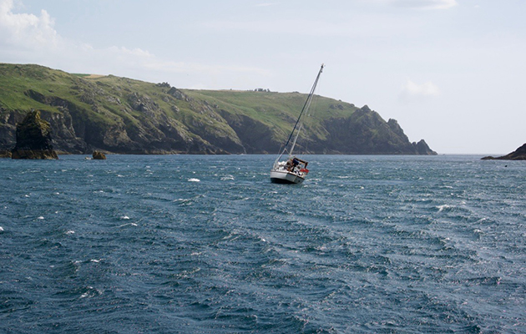

Sailing is like life, it can be a fun-adventure that can take you as far as you can dream, although you must always expect some storms ahead you will need to weather through.

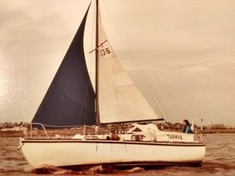

**Anne Allingham’s poem is by Minnie Louise Haskins, Anne says -**

This is a picture of the poem that belonged to my grandma/grandpa.

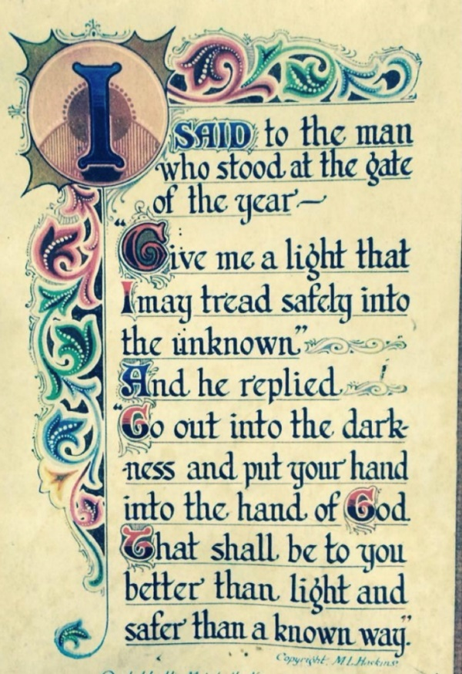

It was in a frame on the wall and, when we were children, grandpa would read it to my sister and me. Sadly this isn’t the original which was much nicer but it’s very similar.

It brings back such lovely memories of grandpa whom I was very close to as he lived with us until he died when I was eight.

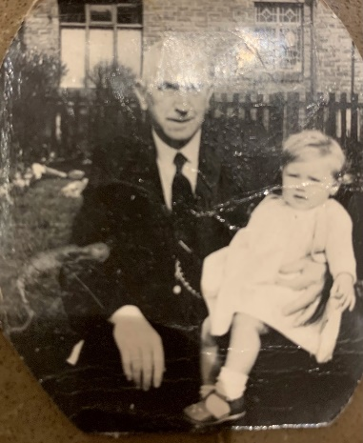

Grandpa and me.

**Dianne’s music lyrics are from the 1960s, they bring her memories of her home town, she says -**

I grew up in Widnes and it’s widely agreed that Paul Simon wrote the opening words of this song while sitting in our local station. In 1965 the town was known for its chemical works - and its very successful rugby team. It looked (and smelled!) like a typical northern working-class town.

According to Wikipedia, Simon is quoted as saying "If you'd ever seen Widnes, then you'd know why I was keen to get back to London as quickly as possible."

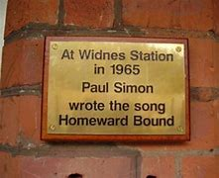

In fact, Widnes station is a nice traditional station a mile or so from the centre of town in a leafy cul-de-sac. The trains went to Liverpool in one direction and Warrington in the other and I have happy memories as a young teenager, sitting with my friends, waiting to head off for an exciting Saturday afternoon outing. Every time I hear the opening words of this song it perks me up, even if that wasn’t Paul Simon’s intention!

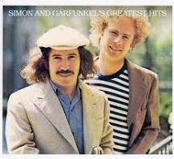

**Homeward Bound**

**Simon and Garfunkel**

I'm sittin' in the railway station, got a ticket for my destination  
Mmh mmh  
On a tour of one-night stands, my suitcase and guitar in hand  
And every stop is neatly planned for a poet and a one-man band

Homeward bound  
I wish I was homeward bound

**Linda Colclough shares a very personal poem with us, she says –**

This is a poem my dad wrote for my mum it always makes me smile and I think of them both now together again in heaven; but mostly it shows a love that never died throughout everything

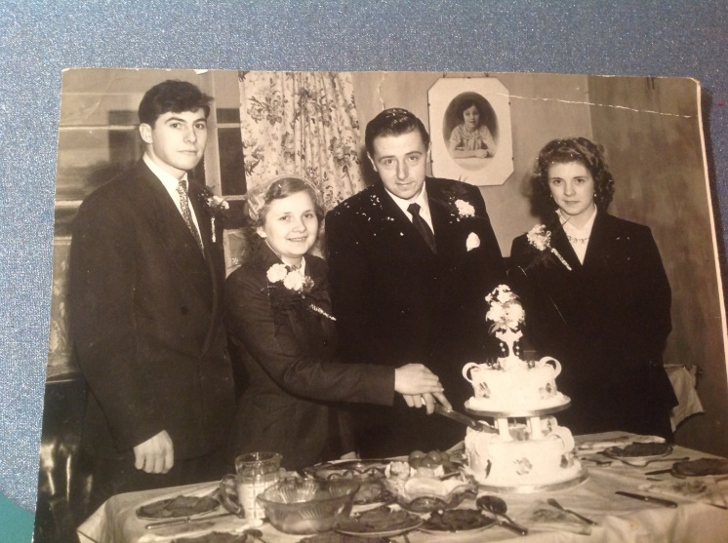

**Beautiful Maiden**

**(Our Love)**

**Ode to Lilian my wife**

Beautiful maiden, soft and fair

As I saw her standing there

Soon enchanted by her charms

I had to take her in my arms.

Pretty soon our love was born

I wanted her both night and morn

So I changed her name to mine

We were together all the time

Next thing you know our love bore fruit

We clothed him in a baby suit

He grew and grew so fast and strong

Then suddenly a girl did come along

Then another, then a boy

They really were our pride and joy.

After a period of rest, from the worry and the whirl

Along did come a baby girl.

She was the last, our family now complete

We at last could find our feet.



So through the years our saga has progressed

I am truly heaven blessed

For in the twilight of my life

This beautiful maid is still my wife.

She cares for me, both night and morn

So even though, with pain I’m heavily laden

I thank God for my beautiful maiden

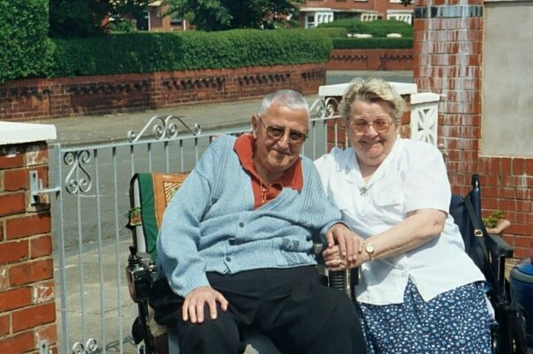

Linda’s Mum and Dad in their later years, Linda says her dad used to write a lot of poems some funny and some more serious.

This is clearly a very personal one, thank you for sharing it Linda.

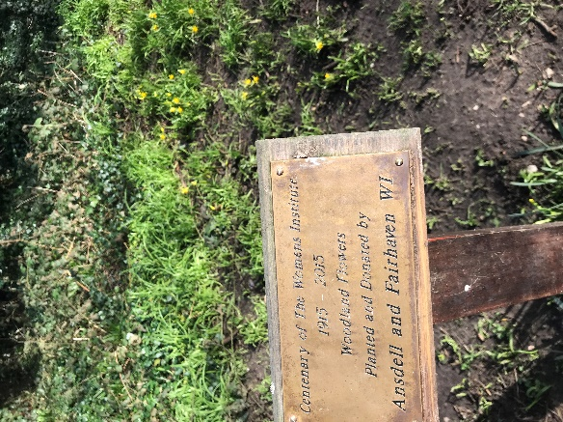Perhaps this could be a favourite A&FWI photo, it’s our planting area in Witch Wood – showing signs of Spring with the daffodils in bud to bring us hope!