**ANSDELL & FAIRHAVEN W.I. NEWS**

**JANUARY 2021**

**www.ansdellwi.weebly.com**

**A MESSAGE FROM THE PRESIDENT**

Everyone is ready for this year to be over. However, turning to a new page on the calendar won’t magically erase all of the hardship that 2020 has brought. The key to making 2021 a better year is going into it with the right mind-set. Look back on what you learned about yourself this past year and if 2020 was challenging, it can be tempting to want to forget about it and leave it behind. But it's when we reflect on what we learned that we really recognize what we're made of and what matters the most.

We survived. We endured the challenges, and some of us even discovered newfound strength. We may not be our old selves, and we may be missing our friends and loved ones, but we are here. And that gives us reason enough to say “thank you”.

I believe that all of us benefit from being part of a community. In the past year all of us have had to adjust to an era of physical distancing. But that doesn’t mean we should be truly distancing ourselves from one another in the communal sense. Whether it is a social group or a civic cause, a study group, WI courses and meetings, commit to being a more engaged community member in one way or another. By finding new ways to embrace togetherness, we will not only surround ourselves with people who share our passion, we will feel a stronger sense of connection to a greater good.

Despite our greatest hopes for an easy year, 2021 will chart its own course, and there is no doubt that it will bring twists and turns as well as hardships and heroics. But by applying optimism and effort, each of us can alter the way we personally navigate the year ahead.

***And THAT is one New Year’s resolution we can all commit to keeping.***



Our January themes are Merry Christmas and a Happy New Year. I know there wasn’t much of a “window” for you to get your Merry Christmas photos to me, so thank-you to those of you who managed it and my apologies for having to “fill gaps” with a few of my own!

The Happy New Year theme is looking at our WI opportunities and activities for the coming year; we are very grateful to Tracey Garvey for her excellent article about what Denman has to offer.

LFWI also offer lots on on-line opportunities for coming together, you will find more details on the back page.

Our own meeting on **Tuesday 12th January** is an inspirational talk by Misba Khan about her involvement in an all-female expedition to the North Pole! **Please do join us for this very special presentation.**

**JANUARY BIRTHDAYS**

Wishing all our January “babies” a very happy birthday

Jacqui Winterbotham

Helen Barker

Joan Shaw

Joan Kettle

Dianne David

Gillian Race

Janet Whalley

**Brenda Kipling**

**CHRISTMAS BAKING**

**BY THE BOYS !**

Joyce Hunt’s grandson Albert is doing a sterling job of icing their Christmas cake, ably assisted by **Grandad – Ho Ho Ho!**

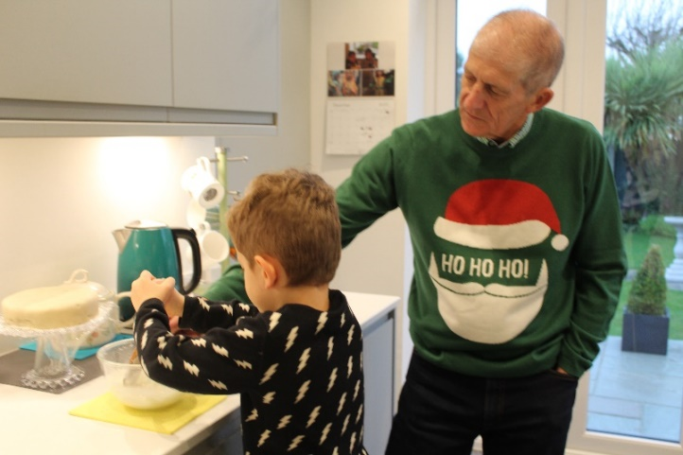

Perhaps we’ll see Albert on Junior Master-Chef before too long.

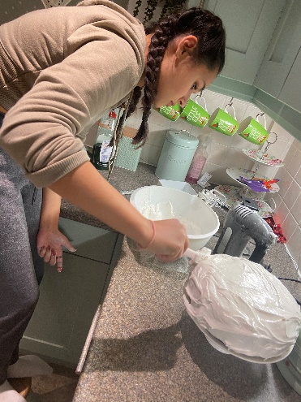

#### Sandra Wolfe’s son Andrew amazed her with the Black Forest Gateau he made for their Christmas festivities – the first cake he has ever made! I think the family will be booking him to bake again for their next celebrations.

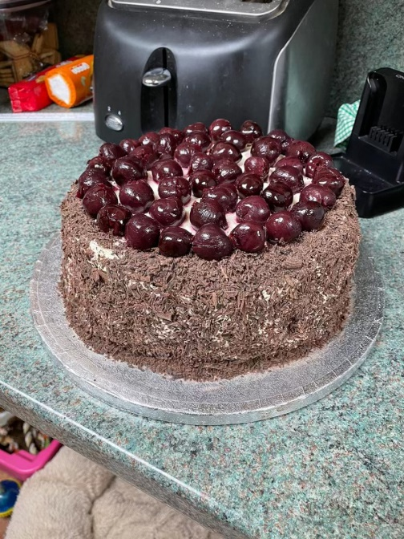

**AND GIRLS!**

It’s many, many years since I made my first Christmas cake – and more than a couple of years since I made my last one! My fourteen year old granddaughter, Elliani, decided she was making her first Christmas cake this year, and like most teenagers, didn’t want any help, (except of course with the clearing up!)

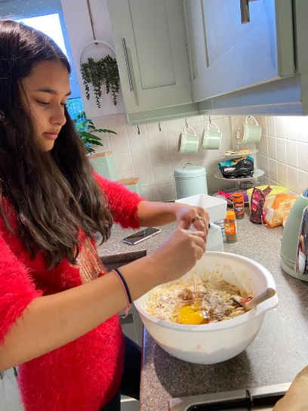

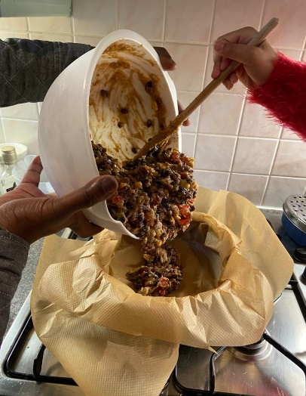

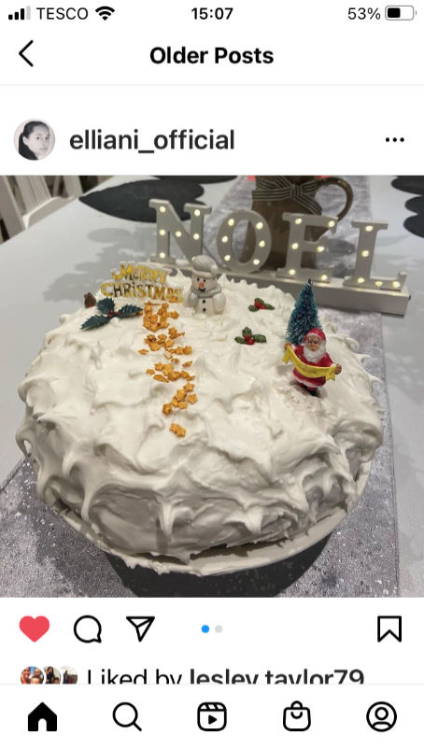

And it tasted just as good as it looks!

**SANTA CAME TO THE “GRAND-DOGS”!!!**

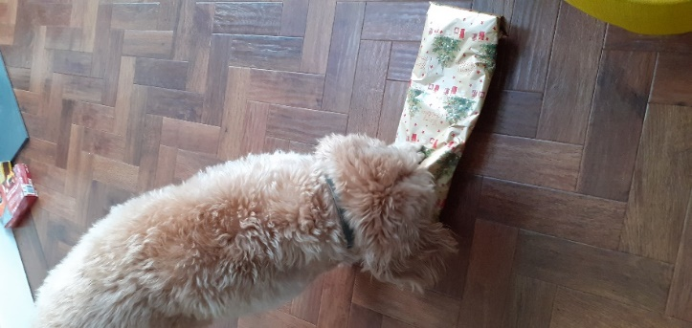

**Julie Swifts grand-dog** Barnie starts off the festivities opening his presents – Julie says he has “no etiquette” He’s clearly just keen to get at what’s inside.

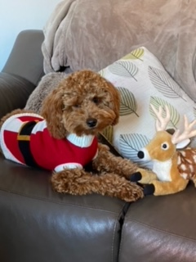Susan Brierley says her 7 month old cockerpoo grand-dog, Lola is definitely a showgirl, “she’s sooo cute and knows it” I wonder if she managed to be as dainty as she looks when she unwrapped he reindeer?

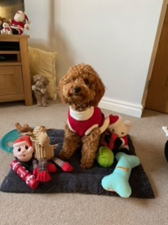

Lola must be on the “good list”, just look at all those presents!

Here is Sandra Wolfe’s grand-dog Mia, at the grand old age of 13 she’s too much of a lady to rip open her present, she employs others do that for her! But she is happy to pose in her present for us all to admire!

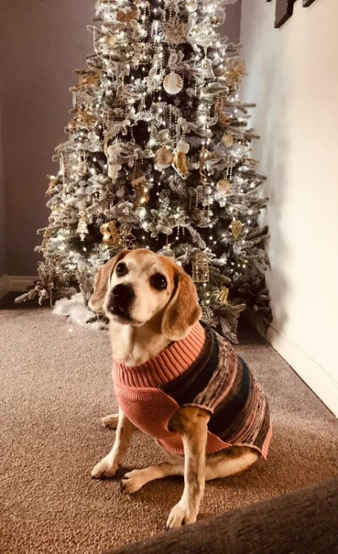

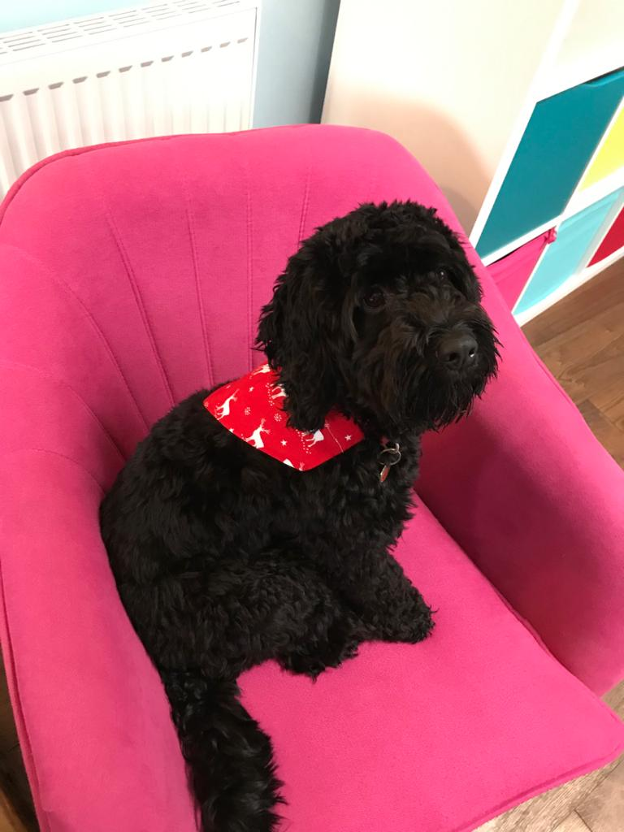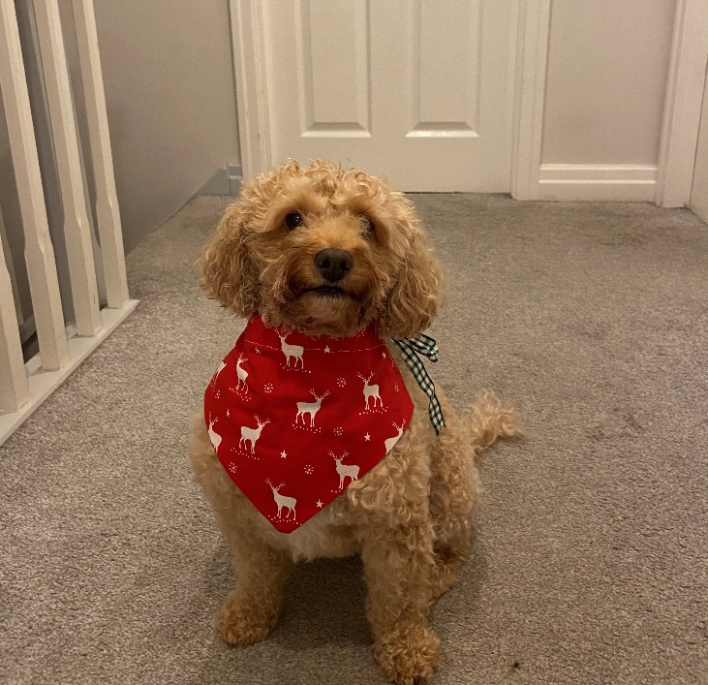And then here are my two grand-dogs, Sandy my daughter’s **Cavapoo**

and Elvis my son’s **Cockerpoo**, they’re posing in the Christmas bandanas I made for them.

**CHRISTMAS WITH GRANDCHILDREN**

Anne’s gorgeous grandchildren, Charlie and Penny are getting so much into the Christmas spirit that they’re now part of the decorations!

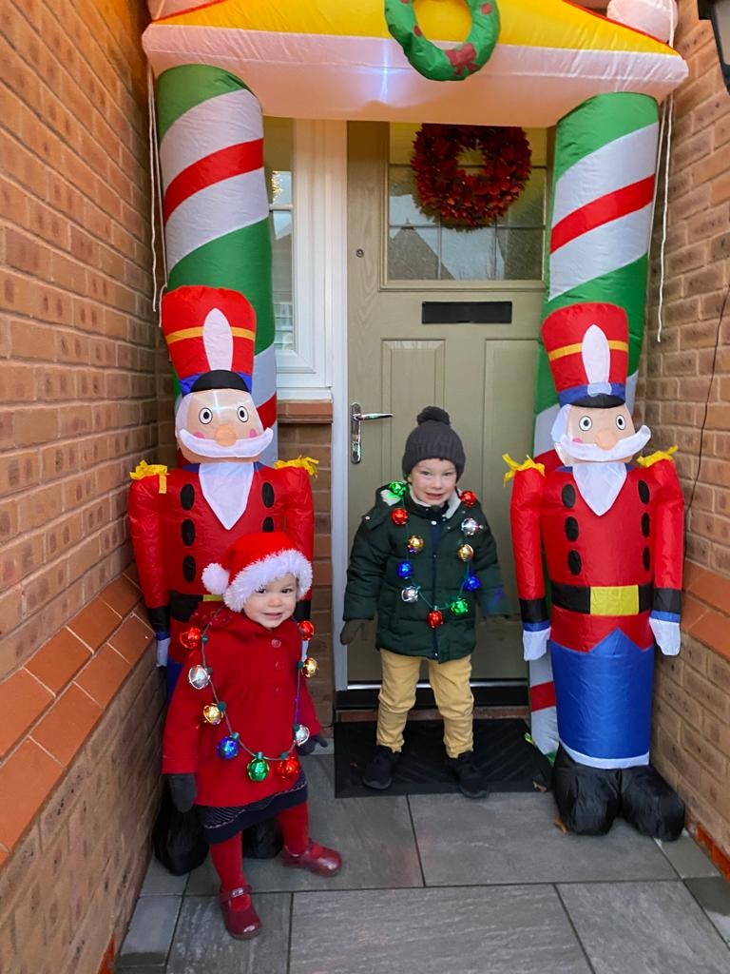

**They’re actually ready to set off to ride the Santa train**

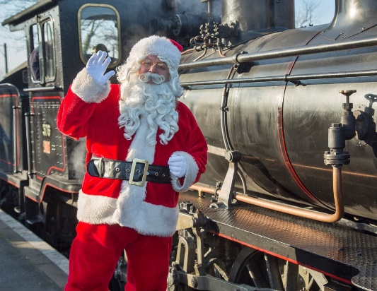

Back home and Charlie is very busy following Santa’s route remotely to make sure he is going to manage to make his deliveries to all the children across the world – as well as to his house!

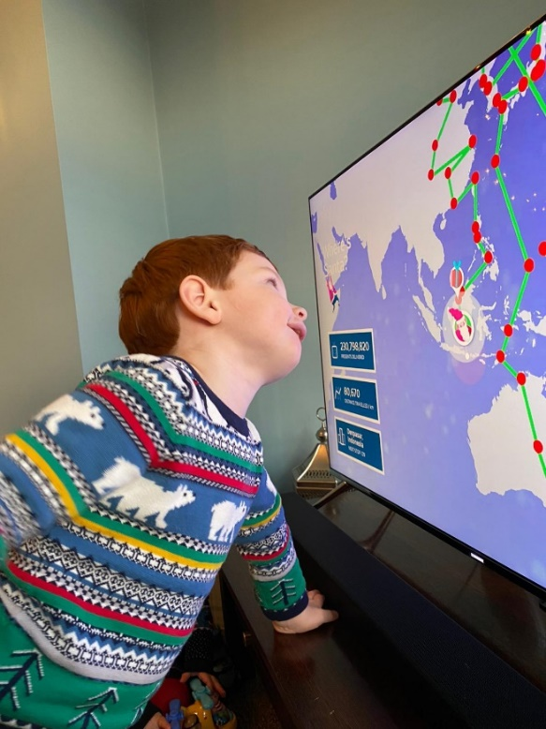

‘‘Twas the night before Christmas” and Charlie and Penny are snuggling down promising to be sound asleep before Santa gets here!

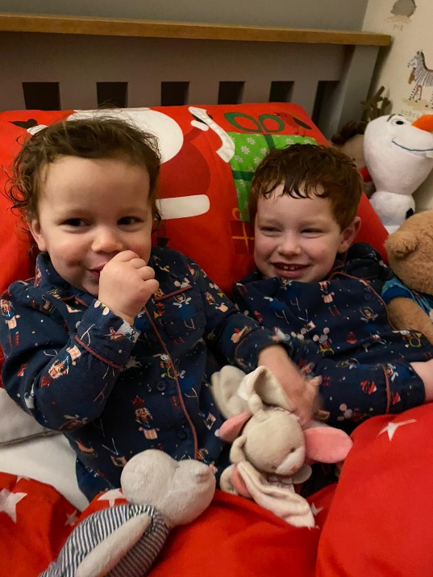

My 10 year old granddaughter Rosa’s hero is David Attenborough, she has all his books and got his newest one for Christmas.

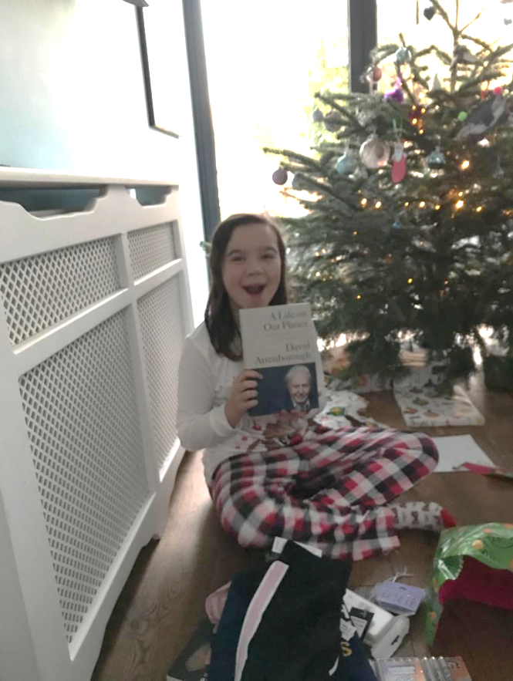

One of her homework projects last term was to compare a Victorian character with a modern day one, she compared David Attenborough with Charles Darwin!

I suggested she send David a copy, she did, and was over the moon when the postman delivered a hand-written reply on Christmas Eve! “The best Christmas present ever!” says Rosa.

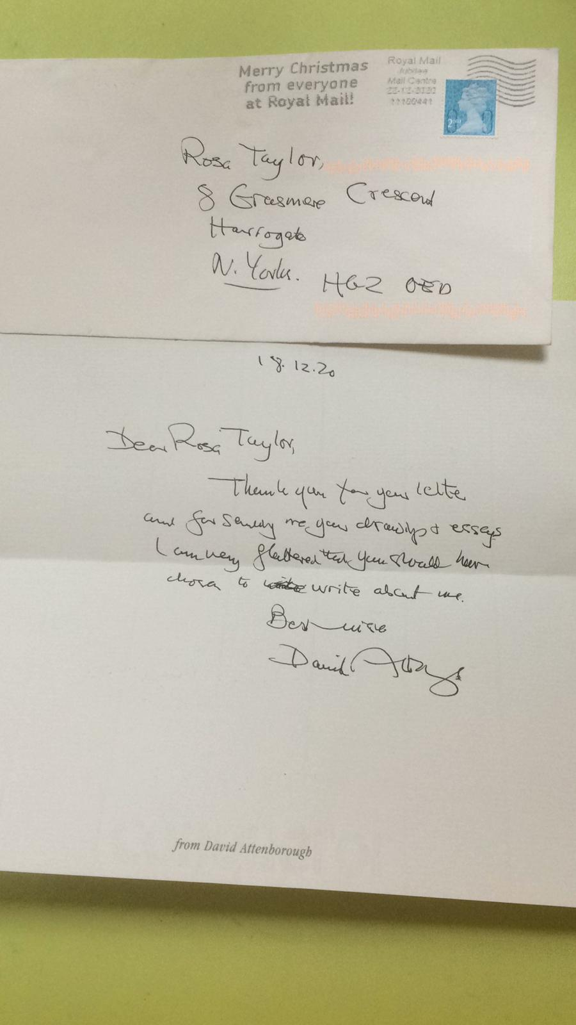

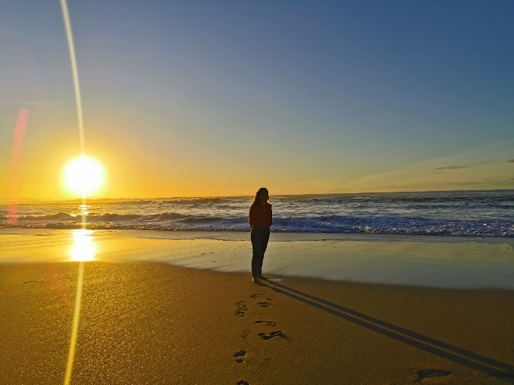

Pat Blundell says - “Peaceful evening walk on Doninos beach, northern Spain. My granddaughter Aida home from Germany for Christmas.

Pat felt very fortunate to spend Christmas with her daughter and some of her grandchildren, but like most of us very much missed those she couldn’t be with, some of whom were many miles away from her, including Aida.

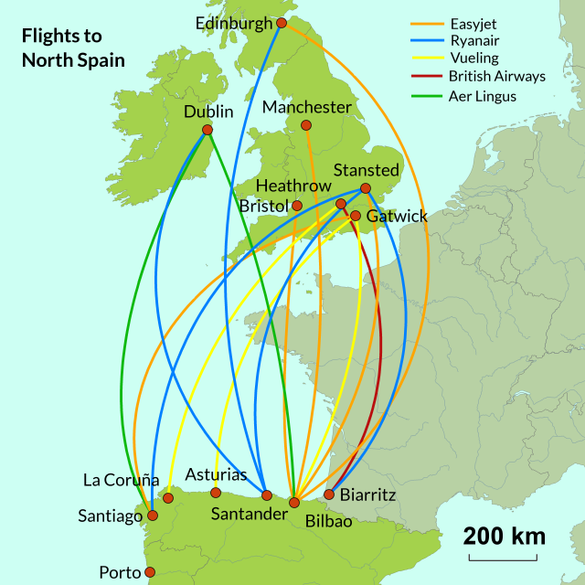

The photo helped Pat feel a little closer to Aida and the rest of the family

Joyce Hunt goes to Christmas Markets every year and always buys a special bauble. These are her favourite ones.

**SPECIAL CHRISTMAS DECORATIONS**

Barbara Knowles loves the beautiful Willow Nativity set she was given for her birthday in July!

She says “This is what Christmas is all about”

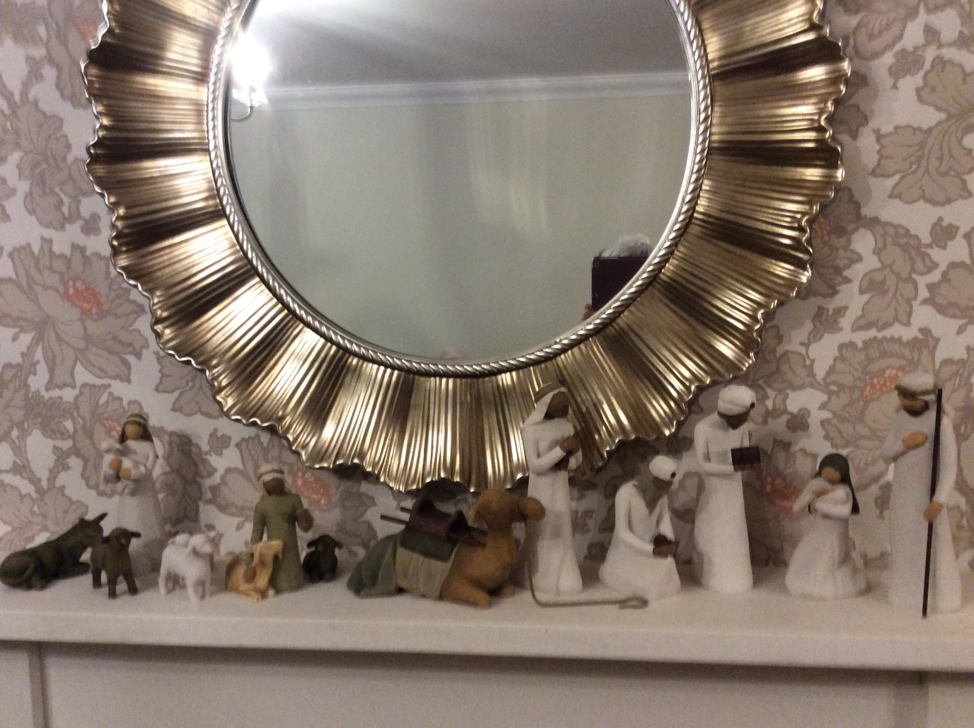

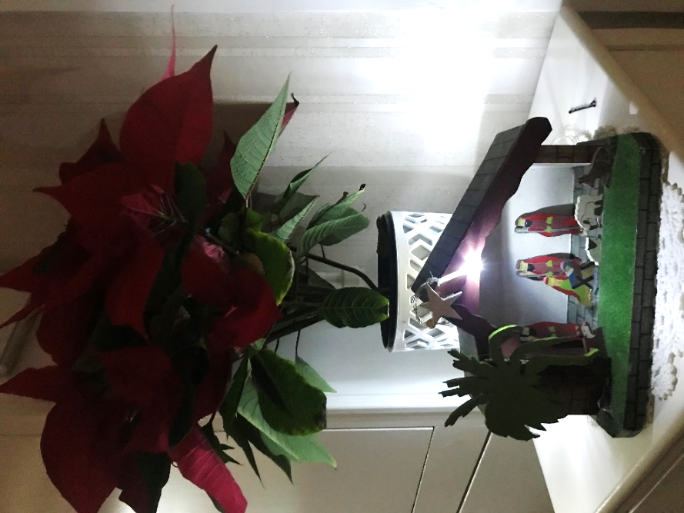 The White Tree is from Bath, the white bauble saying Merry Christmas in Welsh is from Betws-y-Coed, the green one is from Prague and the other white one is from Budapest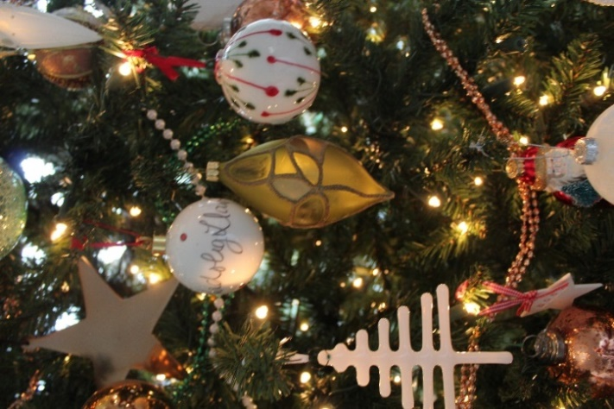

Here’s my favourite decoration, it’s a nativity my dad made for my two children over 40 years ago, it holds so many memories.

Start your Happier New Year with a host of WI activities

**Denman at Home**

*(by Tracey Garvey)*

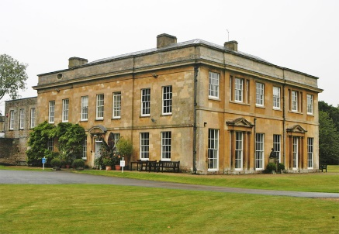

I’m lucky enough to have been able to attend two residential courses at Denman.

Both were excellent, but the journey was either a tedious lengthy drive or a multi train changing ordeal, so I can understand why many members never got round to going.

Sadly Denman residential is no more, but we still have the chance to benefit from the knowledge and expertise of the tutors via “Denman at Home”, one positive to have emerged during the past six months.

There are lectures on history, art and architecture …



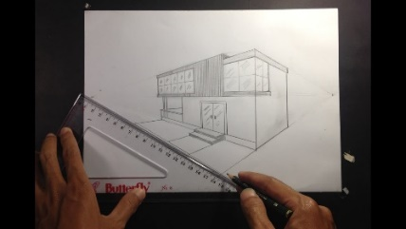



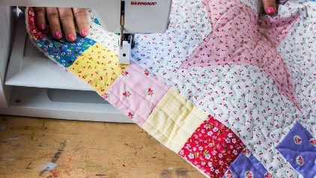

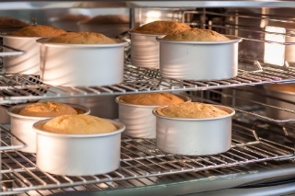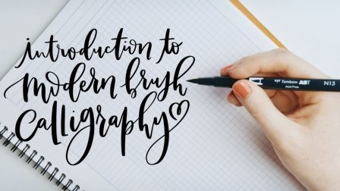…as well as lessons in sewing, patchwork,

calligraphy, and

baking

All are available, very affordably priced at just £5 each, and without the need to go beyond your own sitting room.

What an irony that in these sad and difficult times there’s now a real opportunity for more W.I. members than ever before to experience Denman in its new manifestation, and I would wholeheartedly recommend these sessions to anyone.

If you haven’t tried one yet, please do have a look at the offering here: <https://www.denman.org.uk/whats-on>

What have you got to lose?

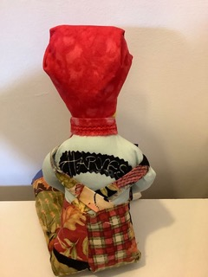Here’s a Land Girl Doll Tracey made with Denman at Home

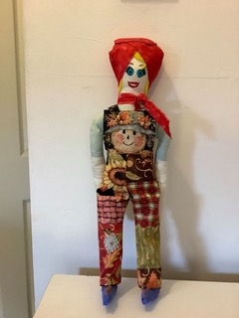

Now you must be ready for a cup of tea – but you need to pour it before 12th night if you want one out of Tracey’s favourite tea-pot with its matching tea-cosy!

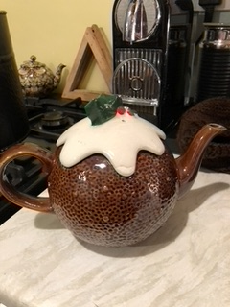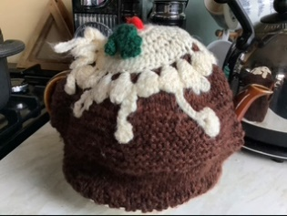

LFWI Programme 2021

## Online events – January 2021

## Ken Pye – Tuesday 5th January 2pm

## The Story of Wirral – A rapid ride through the history of this wonderful Peninsula

## Chef Alex - Tuesday 12th January, 2pm

## Vegan/Vegetarian Comfort Food

## Al Sylvester MBE - Thursday 14th January, 7pm

## Royal Air Force Mountain Rescue Service

## Frances Carlaw – Saturday 16th January, 2pm

## More Pearls of Wisdom

## Sarah Slater - Wednesday 20th January, 7pm

## Secrets, Scandal and Salacious Gossip....

## Penny Simmonds – Saturday 23rd January, 2pm

## Hand Reflexology

## Jo May – Tuesday 26th January, 7pm

## Spoon Playing

## Heather Williams – Wednesday 27th January, 2pm

## Live cook/watch along making Chorley Cakes and Eccles Cakes from the LFWI Cookbook

## (entries for The Show!)

## David Allen – Thursday 28th January, 7pm

## ‘Manners Dearest’

Full details on all these online events will be available a week before each event on our Website and Facebook and will be emailed to all WI Officers. You will be able to book them on the online store at [**www.lancashirewi.org.uk**](http://www.lancashirewi.org.uk)**. All events are priced at £5.00\***

**Please feel free to pass this information to friends and family as these events are open to non-members**

**Please note you do not need to have a PayPal Account to make the purchase, just follow the instructions on the payment page**

**RESPONDING TO THE PANDEMIC**

Some of us must stay at home  
And not go out the door  
Some of us are working  
Like we’ve never worked before

Some of us are keeping busy  
Doing lots of jobs  
Some of us have given up……  
We’re turning into slobs

Some of us have lots of friends  
To text with and to phone  
Some of us have no one  
And feel that we’re alone

Some of us feel positive  
And think that we’re in charge  
Some of us feel anxious  
And fear the world at large

Some of us are welcoming  
New babies being born  
Some of us have lost loved ones  
And cannot truly mourn

None of us will ever know  
What’s really going on  
None of us will think the same  
When all of this is done

So all of us could choose to spend  
Our days in fear and dread…

**..BUT AT A&FWI WE CHOOSE TO PLAN FOR**

**BETTER DAYS AHEAD**

