**ANSDELL & FAIRHAVEN W.I. NEWS**

**FEBRUARY 2021**

**www.ansdellwi.weebly.com**

**A MESSAGE FROM THE PRESIDENT**

Just recently I started doing jigsaws again, probably for the first time since I was a child. As an adult, I always seemed too busy to sit and ponder pieces that didn’t fit together quickly enough! However, right now, I am finding it peaceful, mindful and even contemplative. The latest one, slightly more challenging, was a jigsaw of an ordnance survey map entitled “where I live”, with no guide of what the final product would look like!

As the days passed, adding one piece at a time, it felt a bit like this year. Last March, we were thrown into thousands of pieces of chaos, and very slowly, one piece at a time, every step of the way, we’ve made a little bit more progress and a piece falls into place. Sometimes a particular piece brings great satisfaction and we can’t help tapping it down a few times for a job well done. There are a few special pieces along the way of every jigsaw puzzle journey. Is that starting to sound familiar? Is that how your life is going at the moment?

Reading your stories of your proudest moments and pearls of wisdom have been amazing and thank you for sharing them. They are truly inspirational and many of the “pearls” bring back memories from childhood, given by wise family members. I remember my mentor at work used to say “if you think you can, or you think you can’t, you’re right” which I believe he stole from Henry Ford.

What I am proud of is **YOU**, our members, and thank you for making my role so gratifying and rewarding. I am very proud to be part of such a talented, entertaining, and motivated group. ***THANK YOU!***



“Keep some room in your heart for the unimaginable.” —Mary Oliver, poet.

**THIS MONTH**

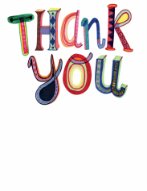

Thank you to all those people who have sent contributions for this month, as you will see they make for very interesting and entertaining reading.



**This month our Zoom presentation is on**

**Tuesday 9th February at 7.30pm**

Our speaker is **Chris Briggs** and his topic is

**Self-Massage**

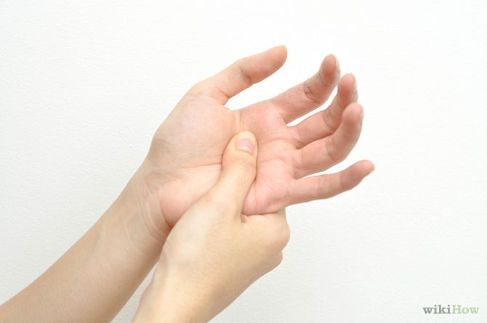He is going to demonstrate and teach us to use several moves to help with mental health, anxiety and pain management. We are told his approach is chatty and engaging and fun!

I am sure that there are few of us who would not benefit from this …

**so please try to join us at 7.30pm on 9th February!**

**Susan will email the link to you this week and again on Monday as a reminder. To access the meeting just click on the blue text, make sure you give it a minute or so to connect before clicking anything else as this might make access more difficult.**

**FEBRUARY BIRTHDAYS**

Wishing a very Happy Birthday to our February babies

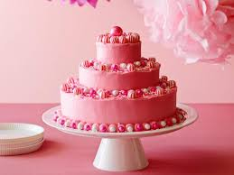

Paula Finn

Lynda Dodd

Eunice Scarlett

WHAT WE ARE PROUD OF

Joan Shaw is proud of her snowdrops.

I’m sure many of us have plants in our gardens which are special because of where they came from or who gave them to us. For me it is my snowdrops and they have an interesting history.

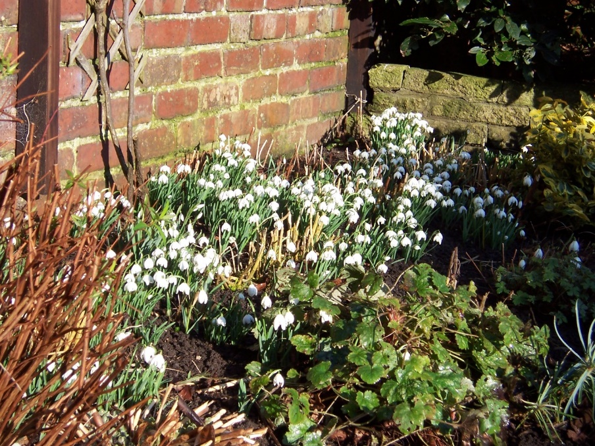

My great-grandmother lived on a farm at Balderstone on the banks of the River Ribble. So the family story goes, she collected snowdrop bulbs which were washed down the river from Whalley Abbey. She propagated these widely and they have come down to family gardens via my grandmother, father and to me. They are just one variety, double and early flowering snowdrops and such a joy at this time of year where they flower prolifically all along the borders.

Not quite the display you see at Lytham Hall but I am proud of them because of their history and continuity. They are a kind of living heirloom.



Rita Kendrew is proud of her part in the Olympics!!!

I volunteered for the 2012 Olympic Games as a Games maker and worked in security. It was an amazing experience and I met some great people.

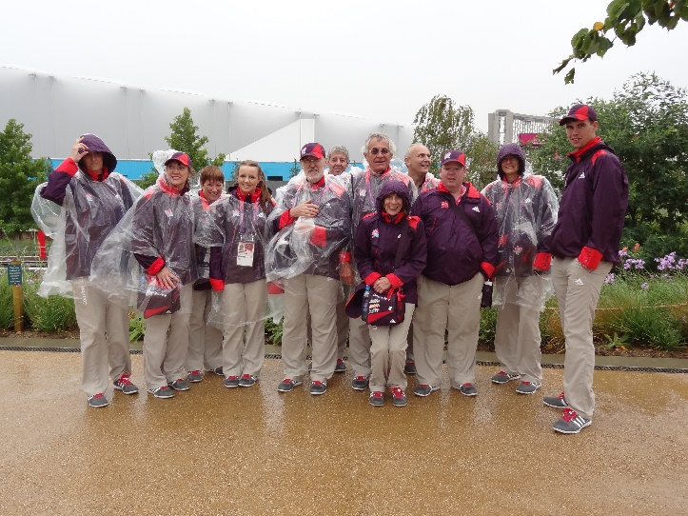

It only rained the one day the rest of the time was really good weather.

Barbara Dobson is proud of this lovely bag

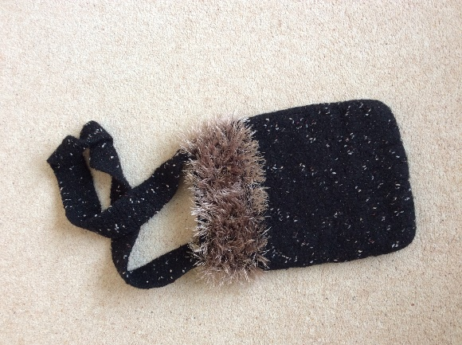Years ago, holidaying in America, I found a lovely wool shop. I found a bag to knit which was easy enough.  The instruction for the felting was the worry as theirs were not the same as our washers, but as you can see it turned out fine.

So I’m proud of that.

Pauline is justifiably proud of her reactions

Being attacked by a wild animal is hardly something to be proud of, but what is, is figuring out a way to survive the attack.

In 2017 my husband Les and I were caravanning in the Ardeche, and on one of our days out we canoed down the river and spotted a couple of wild goats being fed tit bits by walkers, decidedly against the advice offered to visitors.

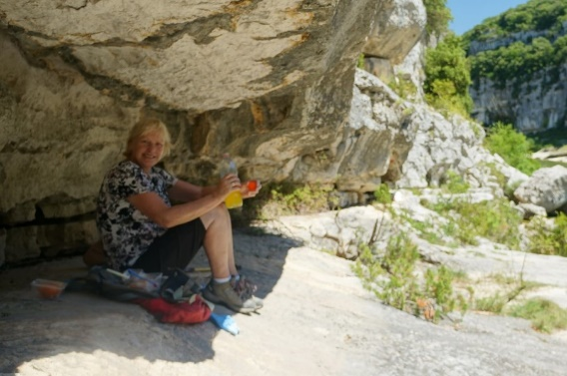

A couple of days later whilst walking in the gorge, for a brief period I was alone, minus any food incidentally, and it was then that the wild goat attacked me.

Without going into details, I had known that the goat was going to attack, and I recalled reading of a lady farmer who was attacked and killed by her ram, so I knew I was in a dangerous situation.

They say that a person reacts to danger by “Fight or Flight!”

Well.......Fight was out of the question - he had big horns and I had my very small rucksack. So too was Flight....nowhere to run to. And nobody in sight to help me.

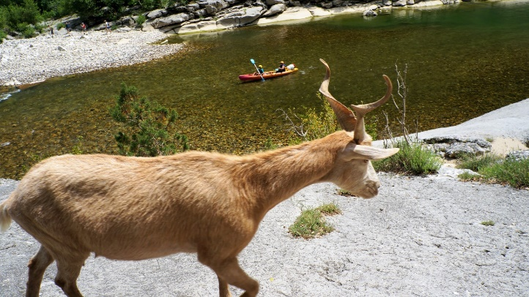

So why am I proud? Simply because I didn’t panic (what would be the point!) but stayed calm and analysed my situation. I reasoned that my only course of action was defence. I mentally ran through my options and any possible outcomes and decided to try to minimise the force of the goat’s attack by finding a good defensive position.

This I did. As anticipated the goat attacked - for a sustained period, until eventually it chased away by walkers who chanced upon the scene. And so I survived, with injured pride and fortunately nothing worse than a colourful assortment of bruises.

Incidentally when we returned home there was a parcel waiting for me, from our son David who lives New Zealand. In it was a highly amusing and very appropriate mug which certainly made me laugh.

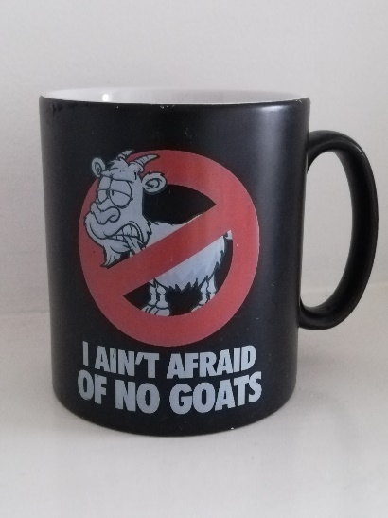

Anna is proud of her Sky Diving!

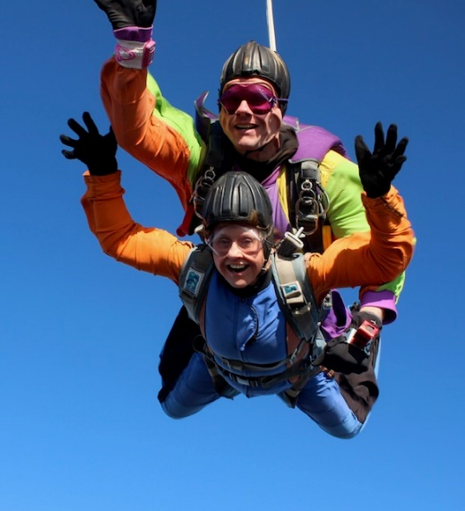In October 2018 I completed a Tandem Sky Dive at the London Sky Dive Centre.   
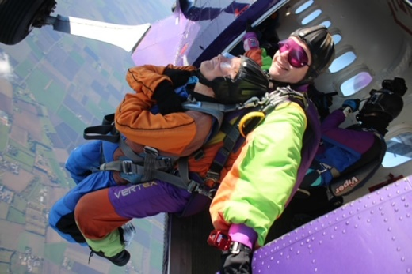My three sons thought it was a great present for their 67 year old mother!!!  The sky five was really outside my comfort zone but I was determined to do it in order to raise money for the Christie Hospital in Manchester, where my husband received treatment for cancer.

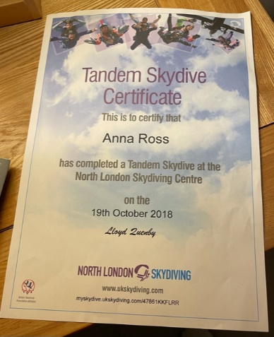It was very scary but totally amazing.   
I am so proud that I had the courage to do it and **raised** over £1000 for the hospital.   
All money raised allows them to fund new developments and research and buy specialist equipment.

Rita Calvert is proud of her contribution to promoting Peace

When I lived in Northern Ireland I joined the Alliance Party. It was set up to bring Catholics and Protestants together.

I canvassed for the party both in the Falls Rd. and the Shankhill Rd. and I was very involved with the party.

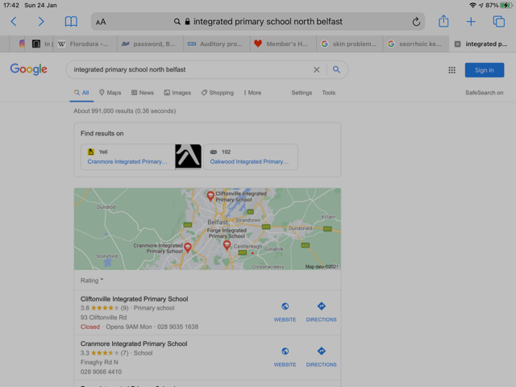We ended up getting 10% of the vote, which although disappointing brought about power sharing at council level and eventually led to a number of integrated schools. I am proud that I was involved.

Jeanette Preston is proud of her long distance walks

I am proud that, in my 50’s with no training, I completed two long distance walks with my husband

One was Wainwright’s  Coast to Coast

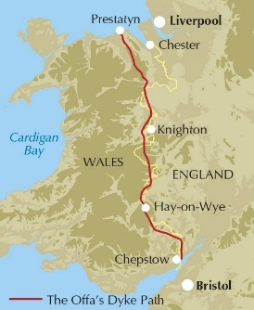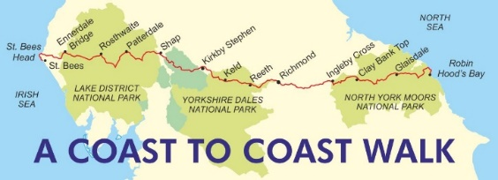

and the other was Offa’s Dyke.

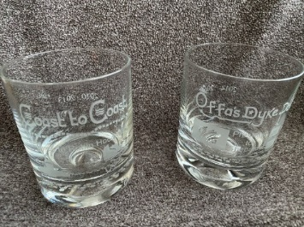Even though it was over a period of seven years, I am very proud of our achievement.

Eliena is proud of her Family Tree Research!

Of the many things I thought of, my family history seemed to be the most interesting. Since I began my endeavours way back in 1983, I have discovered many fascinating people and incidents. For instance, my grandfather’s uncle James Rice, a widower, who was murdered, - shot seven times in a field near Coventry. His assailant believed him to be having a dalliance with his wife. His murderer was tried, found guilty, and sentenced to death but was given a reprieve. The sentence was commuted to life imprisonment.

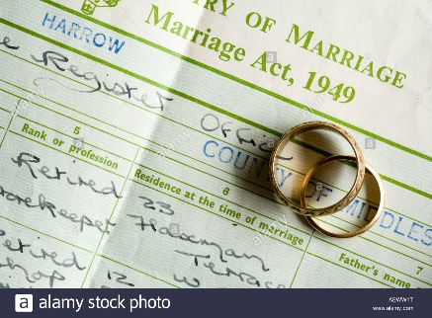Then there was my great, great grandmother Margaret Craig who was married, widowed and remarried by the age of 20. Her second marriage to my great, great grandfather must have raised an eye or two as when they married she was only 20 and he was 48. However on their marriage certificate they both lied and stated that she was 28 and he was 40. Thus reducing the age gap between them from 28 years to 12 years!!! It just shows you that it pays never to take what is written on certificates as gospel.

Recently during lockdown I decided to do some more work on my husband’s tree, his Aunt Mary had married a Londoner during the war while stationed at Weeton Barracks. Sadly, 4 or 5 years after their son Jeff was born, they divorced and went their separate ways. Jeff grew up without knowing his Dad or what became of him.

I was able to establish that Jeff’s father remarried and had another son called Brian.

Brian (and Jeff’s) father died relatively young and his mother remarried. Inevitably Jeff’s family and Brian’s lost touch – and Jeff and Brian grew up not knowing the other existed!

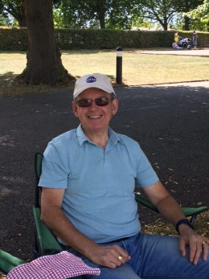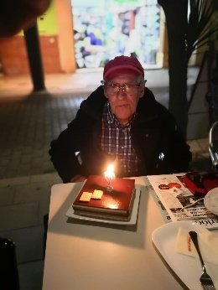**Jeff** As I was making this discovery it seems an uncle of Jeff and Brian died intestate and the solicitors had been searching for them for months to give them their inheritance so finally the two stepbrothers learned of each other’s existence. I was so happy that my passion for family history had led to the two brothers finding each other.

**Brian**

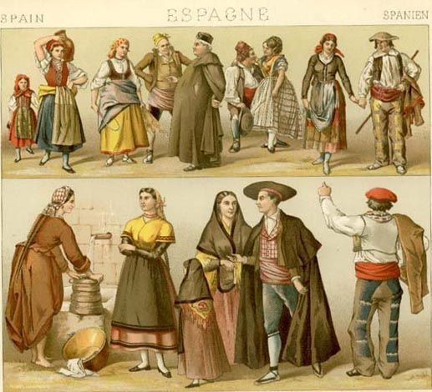Half of my family history is UK and new world based but it is still possible to research my Spanish side too. Some of their church records can go back to the 1500s so I have managed to trace several of my Spanish lines back 14 generations.

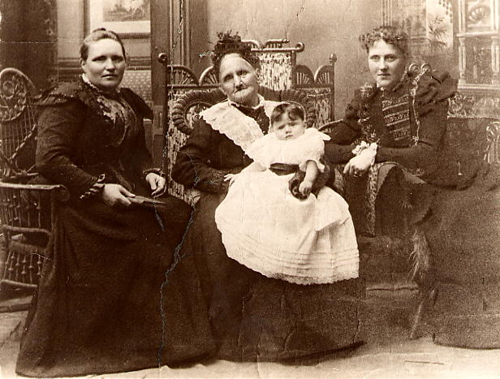And finally my most treasured family history photo. My Gran’s sister Agnes is the baby and with her are my great grandmother Mary , my great, great grandmother Agnes and my 3 x great grandmother Mary who was born in 1822. A great example of the Scottish naming pattern! The photo was taken in 1900.

Marilyn is proud of a family heirloom

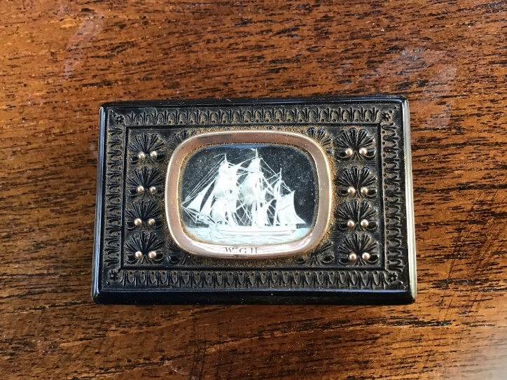

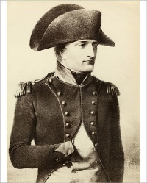

This is a snuff box I inherited when my parents died. The family belief was that it had been given to an ancestor by Napoleon.

The valuer consulted by the executors thought it unlikely as everything Napoleon had was usually gold.

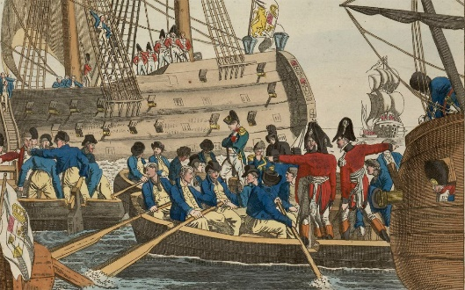However, on looking at the work done by my father on our family tree, we did have an ancestor who was a sailor on the ship that took Napoleon to exile!

There is no provenance, but it nice to think it’s true!

Lorraine is proud of her heritage

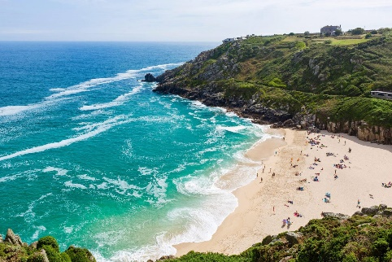What am I proud of - being English.  I know I'm also British but my love of England is Great!  England is beautiful, we have gorgeous countryside, beaches, stately home and estates and very pretty villages.

Despite being very well travelled, it's always a joy to return to England's green and pleasant land.

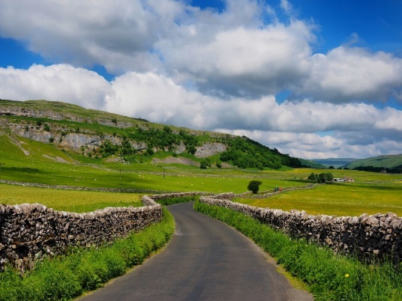

We should all say this with absolute conviction …

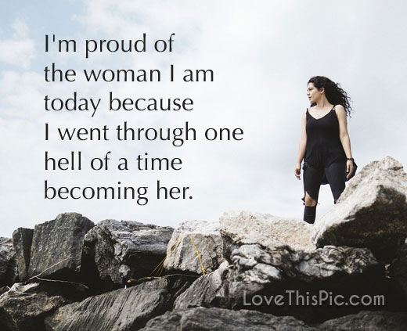

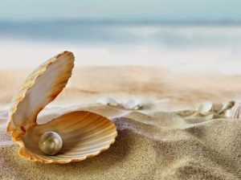**Pearls from Lorraine**

**PEARLS OF WISDOM**

These are the little gems that are the most valuable, often

the most basic of thoughts or, ‘lessons,’ and the

ones that have the greatest impact on our lives

they are our little ‘pearls of wisdom’

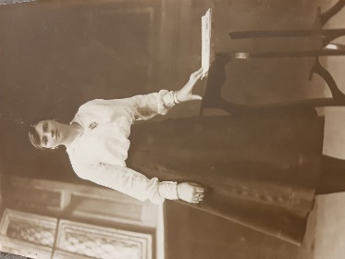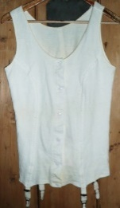My wonderful grandmother gave me two lots of advice when I got married:

*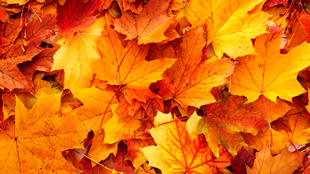Keep your mystery*

* *your granddad has never seen me without my vest on!*

**and**

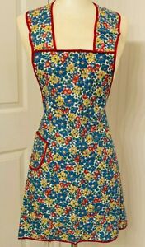

*Always wear a clean pinny on a Friday* (it was the day the men brought home their wages, in cash of course, so you grabbed the money off them and put it in your pinny pocket so they couldn't spend it all in the pub)

Pearl of Wisdom from my dad this time,

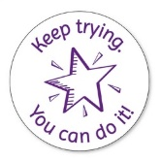 *"The only people who fail are those that don't try"*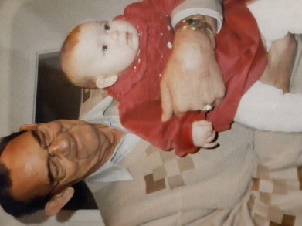

**Susan Brierley’s Pearls**

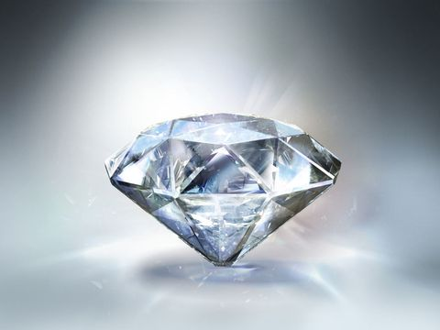*True friends are like diamonds, precious and rare*

*False friends are like Autumn leaves, found everywhere!*

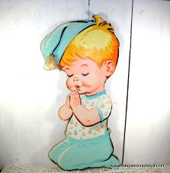

*You should say your prayers every night, not just when you want something!*



*Save the pennies*

* and the pounds will look after themselves!*

*If you can’t afford it, don’t buy it!*

I can still picture Granny saying these.

Lovely memories

**A Pearl from Jeanette Jones**

Here is a pearl of wisdom which I first came across as a young girl when my Grandpa wrote it in my autograph book.  It has always stayed with me:

*"Love many, trust few,*

*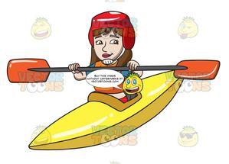 always paddle your own canoe".*

And a couple of Pearls from Dianne

My father told me when I was young:

*‘always look after your feet, girl – once they’re gone, they’re gone!’*

Seems a scary thing to tell a 10 year-old but I took his advice and, now that I’m 65, I’m glad every time I put my walking boots on and tramp across a muddy field……

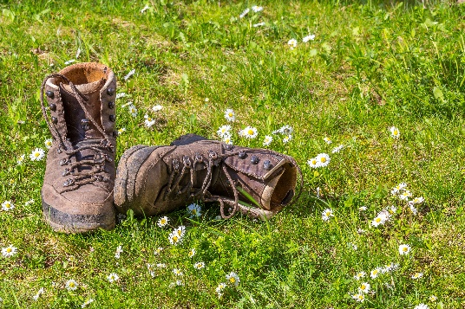

My mother told me

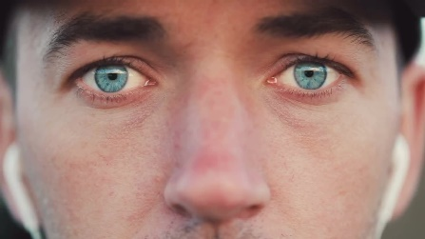*“Never marry a man with blue eyes”.*

Guess what colour my dad’s eyes were?

**A Pearl from Rita Edge**

This is not a hilarious pearl of wisdom, but may be helpful to some people at these difficult times!

It’s something I often bear it in mind.

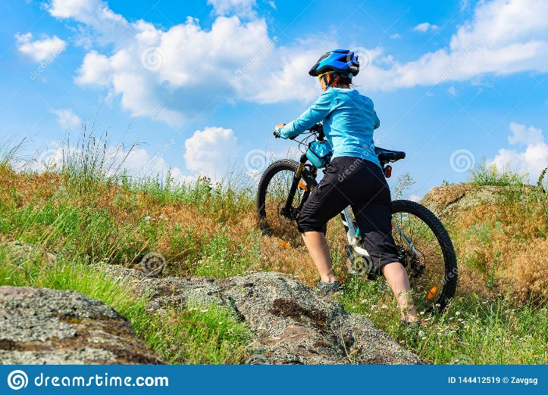

*Here's a little thing worth knowing,*

*When rough and steep the track,*

*All the uphills going,*

*Will be downhills coming back!*

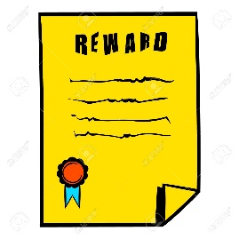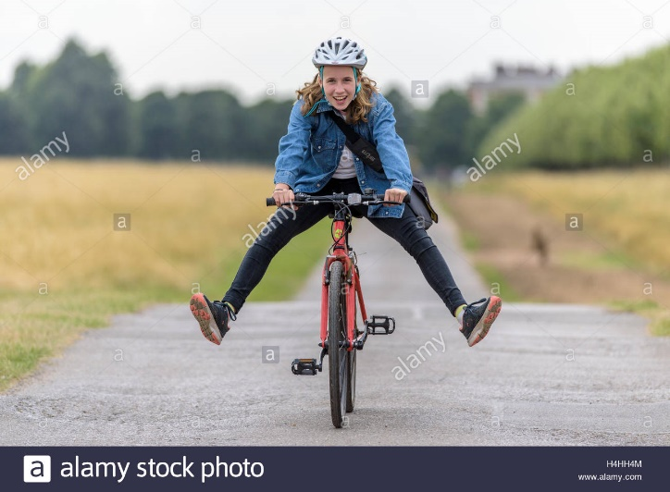

**Pearls from Tricia**

I remembered a Pearl of Wisdom given to me when I was about to become a grandmother for the first time. I was chatting to my hairdresser and, as he has two grandchildren, I asked if he could give me any advice.

"Absolutely", he replied with impressive speed and conviction.

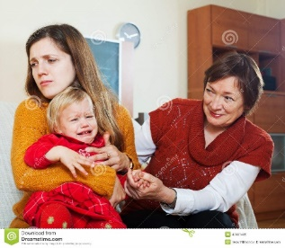"As regards, grandchildren and their parents...NEVER HAVE AN OPINION!"

It was the best advice I ever got and I took it on board so well that my daughter complained to her friends that she could never get an opinion out of me. So I did relent a little....... but with great caution!

Whilst home-tutoring my granddaughter I commented that her work was very untidy compared to what she usually does. I said her teacher would not be pleased with it when she sees it. She replied that it did not matter because the teacher was not able to do anything about it! Well, you can imagine my response!

Nevertheless, it reminded me of my dad. If he was not happy with something I had done he would always say, "**If a job's worth doing, it's worth doing right".** I recall that this was even applied to such jobs as cleaning out the wash-house!

Clearly dad's pearl of wisdom needs to be instilled in his great granddaughter.

I also remember the gems our grandmother gave to Pauline and me when we went to college. Clearly concerned about what we might "get up to" she said:

*If you can't be good, be careful!*

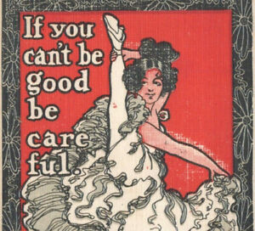

and

*Keep your hand on your ha’penny!*

…. Which as we all know has nothing at all to do with ha’pennies!

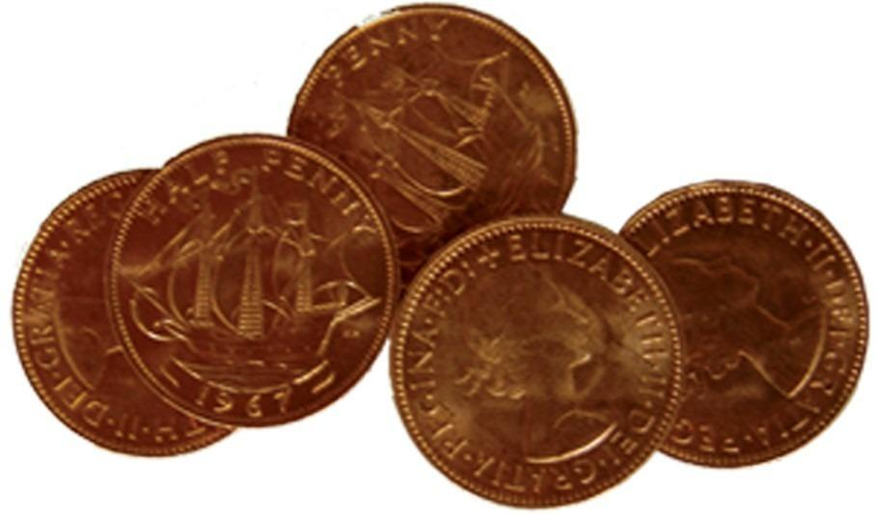

If by any chance you don’t know the meaning of the saying, read the lyrics of the song overleaf!!!

**KEEP YER ‘AND ON YER HA’PENNY**

This was a song sung by the Five Penny Piece in the early 1970s

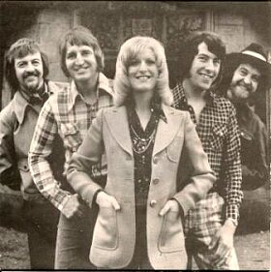

Keep yer ‘and on yer ha'penny

Cover it well with yer palm

Keep yer ‘and on yer ha'penny

And Molly will come to no harm

When Molly began to go courtin’

Her Mother was anxious to tell

How certain young fellows would want her

To stray down the pathway to hell

So Molly’s old Ma used to sing …

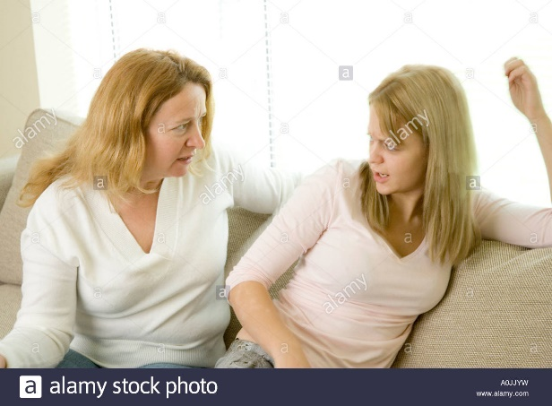

Keep yer ‘and on yer ha'penny

Cover it well with yer palm

Keep yer ‘and on yer ha'penny

And Molly will come to no harm

They’ll hug you and kiss you so sweetly

Make you feel ever so nice

But handle the fellows discretely

And listen to this simple advice

Keep yer ‘and on yer ha'penny

Cover it well with yer palm

Keep yer ‘and on yer ha'penny

And Molly will come to no harm

Now Molly and me went out courtin’

I told her she’d nothin’ to fear

But down in the meadow last Sunday

I whispered these words in 'er ear

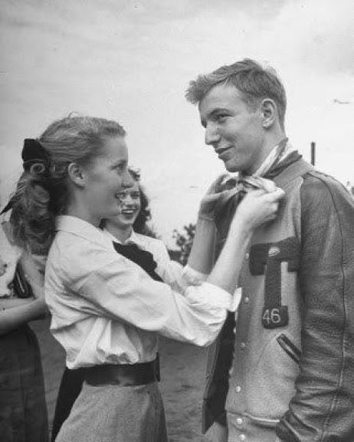

Take yer ‘and off yer ha'penny

Look into me bonnie blue eyes

Take yer ‘and off yer ha'penny

And I’ll give you a lovely surprise

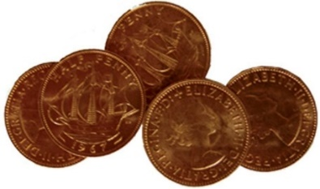

## At Home with LFWI

Online events – February 2021

Tim Mitchell – Wednesday 3rd February - 7pm

Lighting Designer

Ken Pye – Saturday 6th February - 2pm

Notorious Murders of Liverpool

Jenny Mallin – Monday 8th February - 2pm

Winner “Best in World Cookbook” for her memoir book “A Grandmother's Legacy” based on five generations of her family who lived in India during the British Raj

Mark Francis – Thursday 11th February – 7pm

Series 6 Great British Sewing Bee contestant

*Harsha Radia – Saturday 13th February – 2pm

Indian Cookery

Debbie Bradley – Tuesday 16th February, 2pm

Beginners Guide to tracing Family History

Anna Hughes – Thursday 18th February - 7pm

Flight Free!

Richard Pickett – Tuesday 23rd February – 7pm

The Amazing Honeybee

Compiled and Hosted by Simon & Neil Wednesday 24th February – 7pm

A Quiz like never before! –

Heather Williams – Thursday 25th February – 2pm

A selection of Hand-made biscuits

Leila Khasal – Saturday 27th February – 2pm

Paper Tulips

Full details on all these online events will be available a week before each event on our Website and Facebook and will be emailed to all WI Officers. You will be able to book them on the Online store at **www.lancashirewi.org.uk****. All events are priced at £5.00\***

**Please feel free to pass this information to friends and family as these events are open to non-members**

**Please note you do not need to have a PayPal Account to make the purchase, just follow the instructions on the payment page**

**EVEN MORE IDEAS OF THINGS TO DO!**

**Facebook**

Muriel suggested we tell you about **WI Wanderers**, this is a group page on facebook which, amongst other things, is a very good source of online activites.

A very similar group page which is a very useful source of online acitivities, is **Unofficial WI**.

Any member of any WI can join these groups if they have a facebook account. You just need to do a search to bring up the page and request to join the group. Both group pages provide a wealth of varied activities, many of which are free.

Even if you, like me, have not wanted a facebook account before, it’s definitely worth having one simply to access these group pages!

**Bowland Dark Skies Festival**

Thanks to Sandra Wolfe for this information

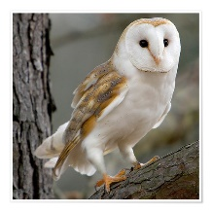This year all the February events are on-line. Their site is well worth a visit – their events include Aurora Watch, Bowland’s Owls, Smartphone Night Sky Photography and a Live Moon Watch. Events are free but you can make a donation.

To find out more just search for the Forest of Bowland Website and Online Events and Learning.