ANSDELL & FAIRHAVEN W.I. NEWS
DECEMBER 2021

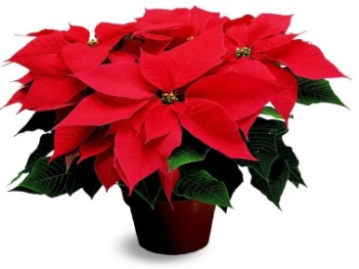
DECEMBER A&FWI EVENTS

Monday 6th December 12.30 for 13.00
Christmas Lunch
…. at The Fairhaven Golf Club

Tuesday 7th December @ 14.00
Knit & Natter
Meeting at the Ansdell Institute Café

Tuesday 14th December @ 19.30
W.I. Meeting
We welcome Samantha White who is well known for her fabulous collections of clothes, her clever use of scarves and how to tie them!

Come along and find that last Christmas present or long awaited gift for yourself!

Monday 13th December @ 19.00
Book Club Christmas Dinner
Meeting @ The County Hotel in Lytham
This month’s book is After the End by Claire Mackintosh

Thursday 16th December @ 10.30
Social Group
Meeting @ Lytham Hall
Let’s meet up and have a mulled wine and mince pie together!

Friday 17th December @ 19.00
Snow White & the Seven Dwarfs Panto
@ The Grand in Blackpool
(we have one ticket still available)

DECEMBER LFWI EVENTS

Friday 3rd December @ 19.00
Brass Band Concert at Chorley Town Hall

Monday 6th December @ 13.30
Heather Williams Cookalong – Festive Entertaining

Wednesday 8th December @ 10.00
Machine Embroidery with Sue Chisnall-Sumner at the LFWI Offices

Friday 10th December @ 10.00
Machine Embroidery with Sue Chisnall-Sumner at the LFWI Offices

to our December babies
Dorothy Williamson
Jay Semley
Rita Edge
Ann Lomas
Elaine Edmondson

W.I. CAMPAIGNS
RESOLUTIONS

(see full details in your
WI LIFE MAGAZINE)

At our January 11th 2022 meeting, our full members have the opportunity to vote for their choice on which Resolution will go forward at the National Federation Annual Meeting.

Resolution 1
Fit for Purpose : Fit for Girls

Resolution 2
Appropriate sentencing of non-violent women offenders

Resolution 3
Equality in law for Menopause

Resolution 4
Women and Girls ASD and ADHD

Resolution 5
Tackling digital exclusion

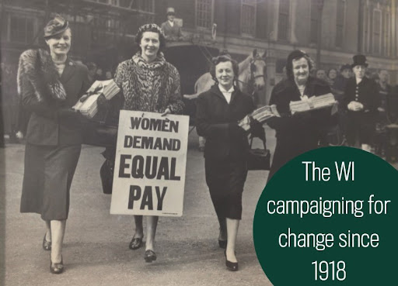

It is looking more positive for the future of our wonderful W.I. We have encouraged new and existing members to volunteer their valuable time to join our Committee and persuaded a few experienced members to stay on for a short while!
Please mark your calendars for the Annual Meeting scheduled for Tuesday 8th February 2022 where you will be able to say hello to your new team and farewell to those stepping down.

