ANSDELL & FAIRHAVEN W.I. NEWS
AUGUST 2020
www.ansdellwi.weebly.com

A MESSAGE FROM OUR LOVELY PAT

A Goodbye from me,

Hello ladies, it rather looks as though my move to Kent will now go ahead on 12th August after so many delays, and now it’s happening quickly. So, I would like to say goodbye to you all and very best wishes for the future of our great W I.

Thank you for the support and friendship I have enjoyed for the last 14 years, since my husband died. Our group has been a lifesaver for me and I will take treasured memories with me.

Good wishes to every member and to the further future success of our group.
Pat Blundell.

And a Goodbye from us,

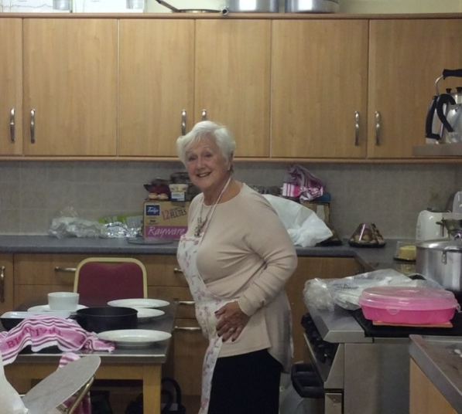

This is the busy, busy, busy Pat we will always remember, busy organising for us, busy creating happy times for us and busy offering comfort and support to any one of us who needed it.

Thank you so much for being such a positive, supportive member of our WI, we will all really miss you. Our love and good wishes go with you, always.

A MESSAGE FROM THE PRESIDENT

Just looking at all these wonderful holiday memories from our members made me realise that by delaying things until the “right” time has most definitely been the wrong approach in life. Clearly, right now and for the foreseeable future, will the time be “right” ever come again for some of us?

I do understand how difficult it will be returning to “normal” especially for our large group. What we need to ensure is that our future meetings are as valuable and enjoyable as they have been in the past.

We, the Committee will communicate with you with clarity, thoughtfulness, and kindness to ensure that you feel secure and safe to return to the fold, when you are ready. Along with the elders of the White Church, we will provide you with the support and guidance you need to ensure that the environment is clean with procedures to keep you safe and sound and, as far as possible, protected from harm.

Sadly, looking at the Guidelines from the National W.I., we won’t be able to sing Jerusalem for a while!!

Our members have clearly been busy with many different lockdown activities and it is a delight to see the results.

Looking forward to catching up with you on maybe another walk, or what about a tea party in the park or on the beach? The weather does seem to be brightening up over the next few weeks, thank goodness!

Thinking of you all, Stay safe,

ZOOMING AND WALKING!
Although we haven’t managed our usual monthly meetings as yet we have had two very enjoyable events in July – Zoom Quiz was great fun even for those of us whose scores were just above “nul point”...
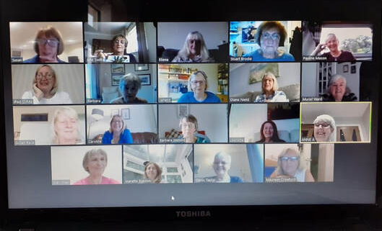

... and our walk around Fairhaven Lake was a joy, very relaxing and sociable even with social distancing!

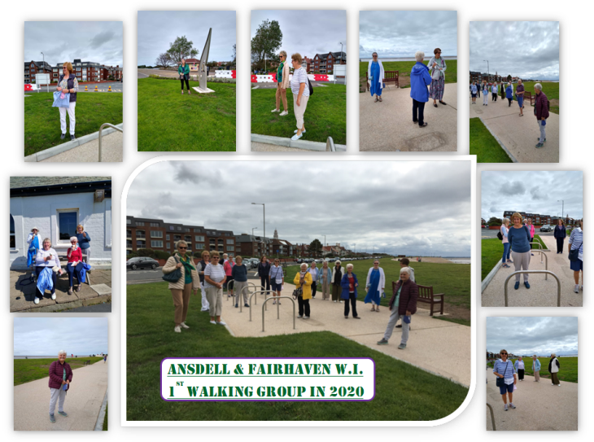

Happy Birthday
to our August Babies

Linda Colclough
Jeanette Preston
Anna Webster
Patricia McGauran
Eliena Sagasti

HOLIDAY MEMORIES
Planning a holiday this year presents lots of questions and no certain answers, a few may venture abroad, some may manage a “staycation” and others may wait till later in the year to decide what to do – but all of us have happy memories of past holidays in here are some members want to share -
Here’s one from Dianne, which is quite topical!
It’s Yellow Crane Tower in Wuhan taken on the 30 April 2019. As you can see, plenty of people, no masks, no social distancing!
Later that day we took the train from Wuhan to Shanghai and our experience in the station was one of the scariest I've had while travelling. It was the beginning of a 4-day public holiday and it seemed as though everyone in the city was trying to get away. I've never been anywhere as crowded as that station in my life, there must have been hundreds of thousands of people jostling and pushing and trying to get on the trains.

When I told my family and friends about this later, none of them had ever heard of Wuhan-
but we all know Wuhan now!

Jeanette Jones has had lots and lots of lovely holidays and so has lots of lovely memories ...

...but she says
“For me one of the most memorable is the first time I looked out over the ancient city of Jerusalem.

It had been a lovely warm day and after pausing to rest for a while amongst the olive trees in the small, peaceful Garden of Gethsemane, we headed to the viewpoint near the top of the Mount of Olives.

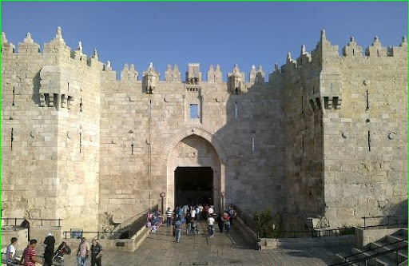

Jerusalem

It was early evening as we looked across at the world’s oldest continually used cemetery and the old city of Jerusalem spread out on Temple Mount - the sun lighting up the beautiful golden Dome of the Rock. Then down via the Damascus Gate into the Old City with its warren of streets and bustling alleyways.

Here in such amazing proximity lie some of the holiest places for over half the world's population.
An indescribably moving place.”

June Oliver tells us that “Whilst visiting our family in New Zealand ...

... there was a long weekend at the end of January when top street entertainers from all over the World were invited to perform in Auckland City’s waterfront area.
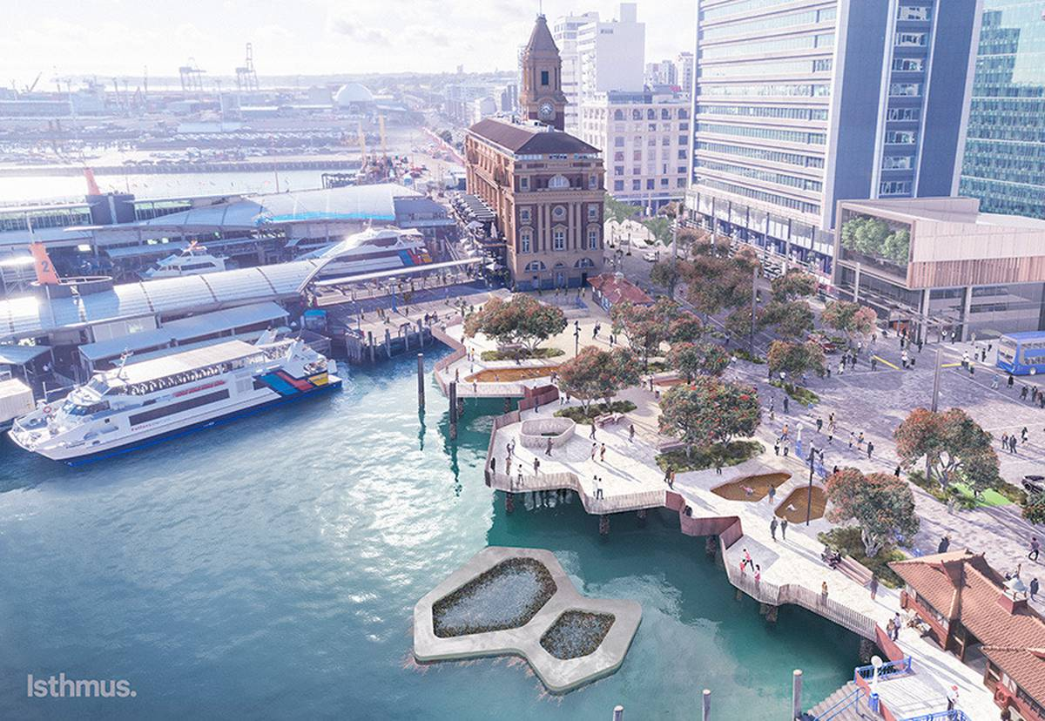

The family, our daughter Catherine, her husband Malo and grandchildren Elliot and Amaya, together with Nigel and I decided to go and see the entertainers - and what a wonderful day we had.
There were magicians, acrobats, jugglers, musicians, singers, dancers, contortionists, comedians - a great variety of performers and performances.

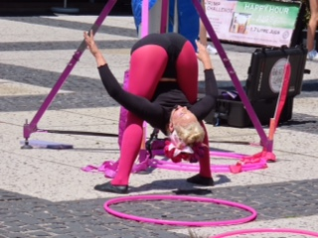
Our 4 year old grandson Elliot volunteered to help a couple of acrobats at one performance, much to our surprise.

The act was very good, and so was he.

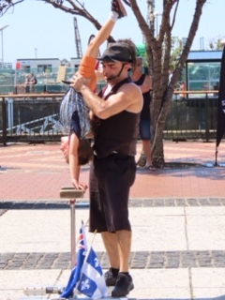

The performances were given freely but at the end of each a hat or a bag was passed round the audience for people to pay what they thought the performance merited.

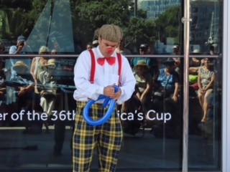

I hope the artists did well the day that we went because the entertainment was excellent.”
Paula Finn has many memories of her holiday in Japan, she has sent us lots of photos, looking at them I get a real feeling of what it like to be there.
TOKYO

The superior form of public transport we relied upon in Japan.

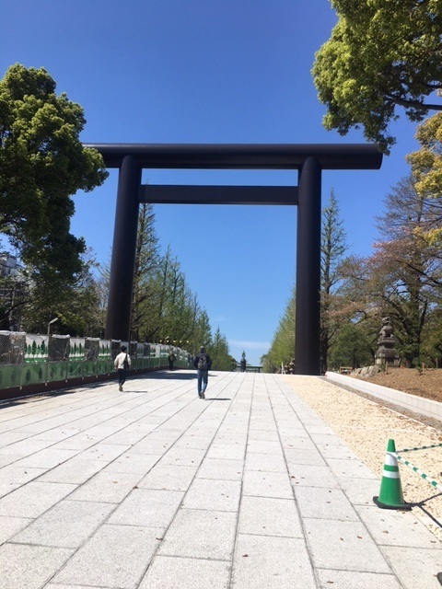
Memorial Gardens in Tokyo.

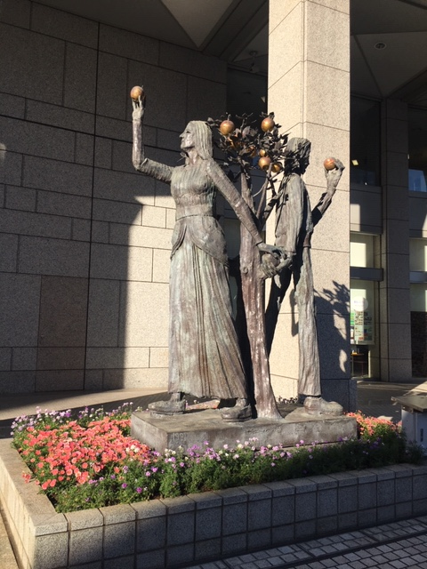

Statue of Adam and Eve in Tokyo

KYOTO
House in Kyoto. Fabulous traditional garden.
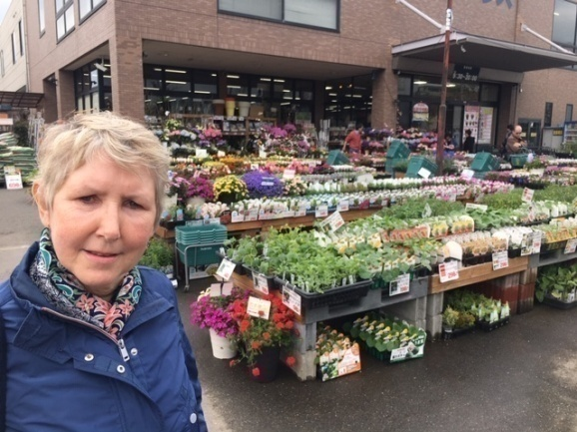
Hardware shop and garden centre in suburban Kyoto, a vast display
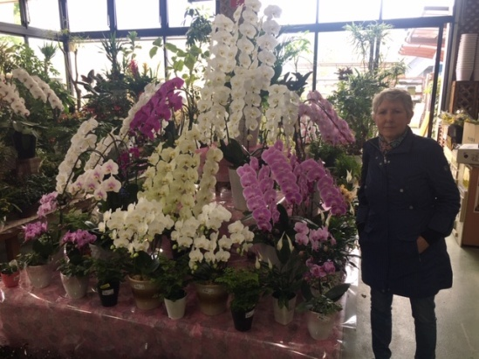
Inside the garden centre – look at the size of those orchids!
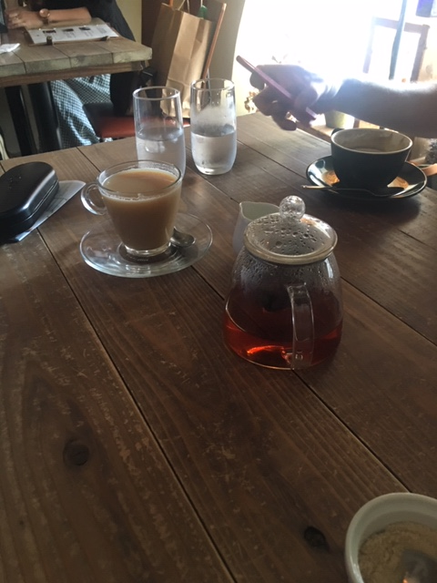
Time for tea at Tea House at Nijo Castle in Kyoto.
HIROSHIMA
Hiroshima - the bomb blast dome.

The Shukkeien Garden was established in 1614 but was re-opened in 1951 after extensive renovations. It houses the Atomic Bomb Victims Memorial. There are different areas in the park with scenes of beaches, mountaintop, great lakes and yawning valleys.
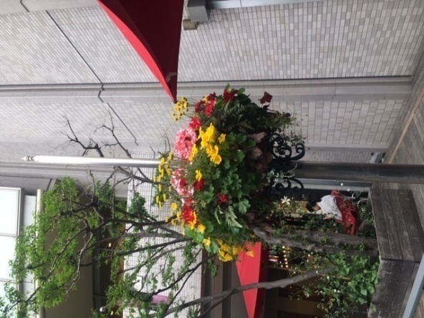
Streets too are alive with flower displays, perhaps making a statement after the terrible destruction!

Hiroshima is certainly the place to eat!
Traditional Japanese cuisine restaurants abound, but many combine foods from other cultures -
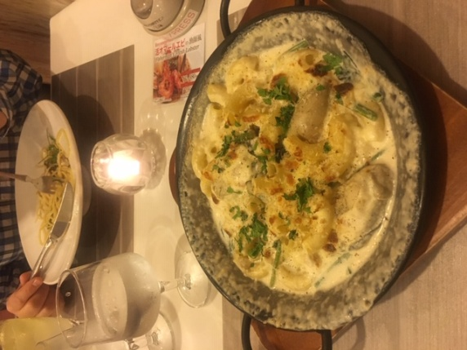
Pasta with Hiroshima oysters ... Japanese Italian style restaurant.
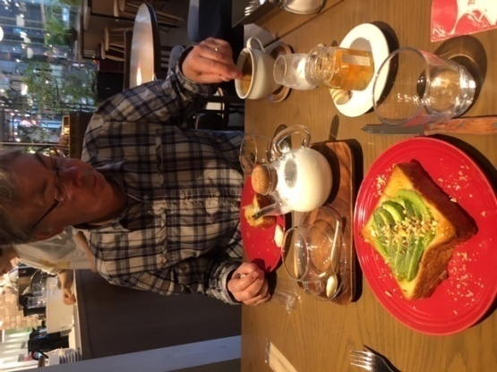
And breakfast – the world’s best toast!

Then - journeying home via Hong-Kong
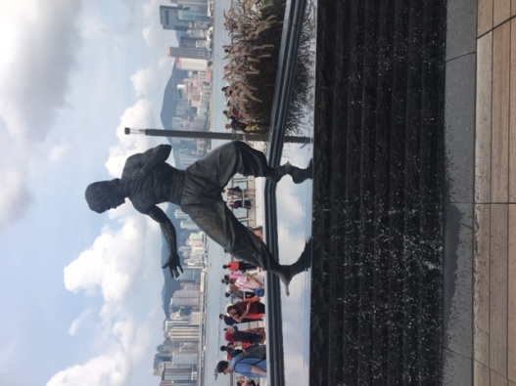
We found Bruce Lee in the Avenue of the Stars

KEEPING BUSY DURING LOCKDOWN!

Lots of members have been busy making lots of lovely things for family, friends, charities or just for themselves!

Dorothy Barrett has been particularly busy, she says
“I love photographs and while going through all my old photos of my nieces and nephews (who are in their 20s and 30s) I decided to use some of the photos to make large collage photo birthday cards for them all. What lovely memories it brought back while making them...... and I have many cards made for the next year. Now I am working on anniversary cards for their parents!

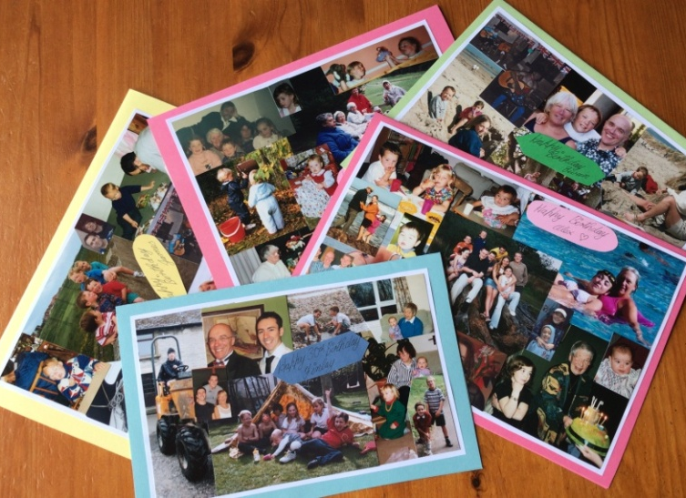
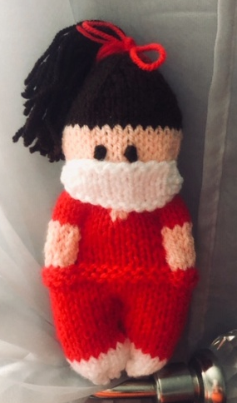
Are you looking forward to a big gathering at Christmas, if so you might interested in making these – Dorothy says she made “60 snowman place settings for a Christmas function out of recycled champagne corks and coffee pods, odds and ends of ribbon, wool and paint ..... and not a penny spent

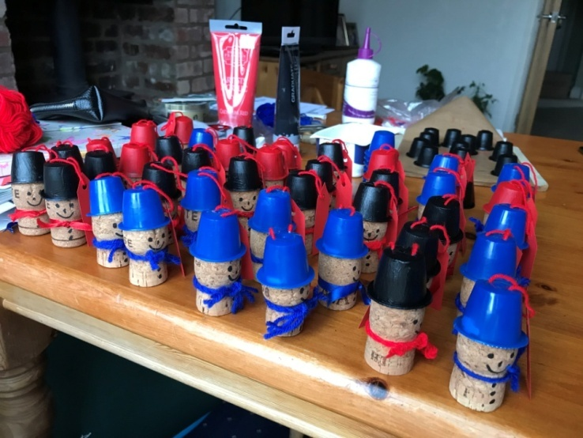

I just love these little NHS dolls Dorothy has made, and you could do so much with them

- give them as thank you gifts to NHS staff
- hang them in your car or window to show how you
value the NHS
- sell them and donate the money to the NHS

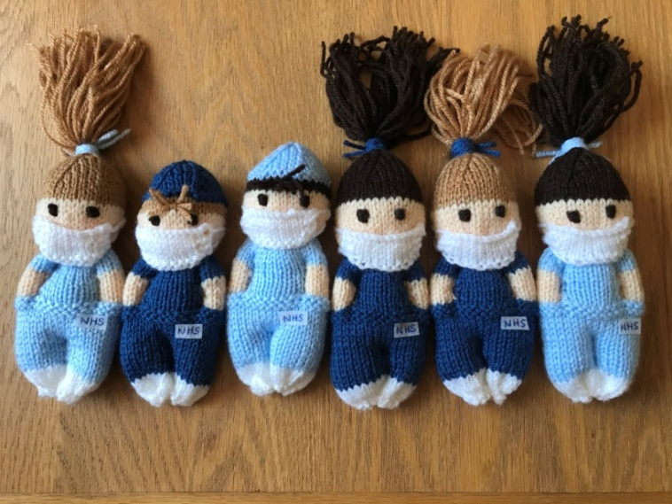

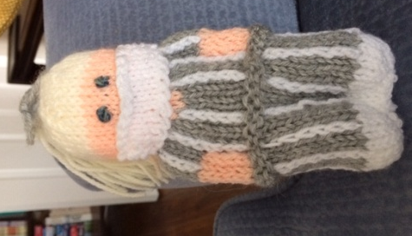
I was so taken by the dolls that I searched out the pattern on the internet and made some – the one in the red scrubs I made for a radiographer daughter of a friend and the grey and white striped one was for a care home manager friend of my daughter.

The pattern is free on ravelry.com, but if you have difficulty finding it just email me and I’ll send it to you. (glenis.taylor@outlook.com)

Christmas is coming!

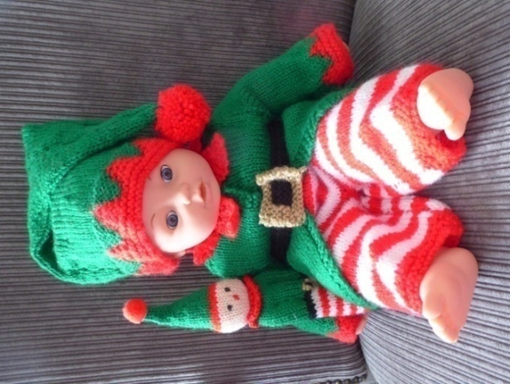
(There is a good reason this little elf is ready so soon before Christmas and it’s not just so she can help Santa!)

Muriel says
“This is a Christmas Elf outfit that I've made for my granddaughters doll. She is 2 and lives in Vietnam so it might have to travel alone this year!

It’s not up to County show standard but I don't think she will notice”

I love the fact that the elf doll has her own little doll and I’m sure Muriel’s granddaughter will love her!

A POEM ON KEEPING BUSY IN LOCKDOWN
Written by a friend of June Oliver

Wise words of comfort for us all.

Busy, busy, busy
Marcia says
“Have tried to keep busy during Lockdown, I haven't been out much since March 16, just a couple of walks. Managed to have birthday on my own but the phone rang about 20 times and I had 42 cards. The thing that kept me sane was my WhatsAp group with Janet's crochet group who chat all day and so you don't feel so lonely. I'm also lucky have a garden and greenhouse which keeps me busy”

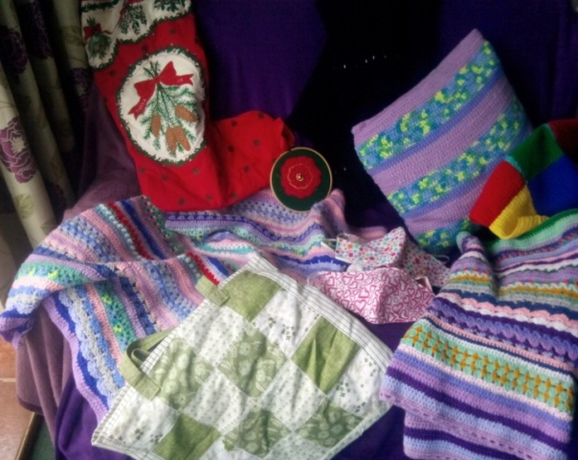
“I've made a couple of blankets thanks to joining Janet's crochet group, also cushions, masks, bags and some things for Christmas thanks to Linda, as well as a few things I've given away as presents.
I miss the WI and all my friends, love to all Marcia”

KNIT AND NATTER
Maureen says some members have been busy knitting squares for the Blackpool Victoria Hospital Great BTH Knit. If any members have any knitted or crocheted squares to send please could they let me know so I can collect them and send them from WI.
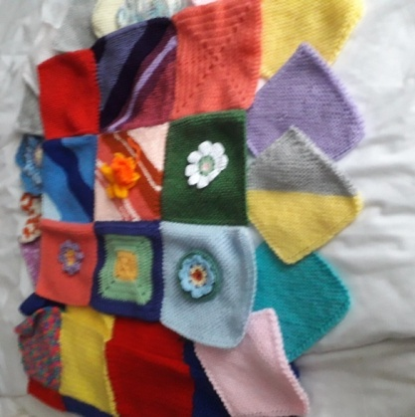
As it is likely to be a long time before the knit & natter group can meet in the cafe I wondered if members would be interested in doing a meeting by Zoom. Please email if you would like to do this.

Keep up the knitting & crocheting ladies. I look forward to hearing all about your projects.
Maureen xx
BOOK CLUB

This month’s book begins with Queenie in a Hospice in Berwick on Tweed, run by nuns. She has incurable cancer of the face.

The story begins with a letter that Queenie feels she must write to Harold Fry (who was her driver after she got a job as an accountant at a brewery in Kingsbridge, lovely place) She’d gone there after leaving the man with whom she’d become pregnant and he didn’t want to know.... she lost the baby in her second week in Kingsbridge. How she acquired the job as accountant, how Harold becomes her driver as she goes round the various pubs validating their accounts and meets his son David is good reading. She falls in love with Harold (does he realise this and does he love her??)

In her second letter she says “I will confess everything, my secrets have been inside me for 20 years, I must let them go before it is too late.” Harold says he will walk the length of England to get to her and sends her postcards all the way up. She tells of meeting David, Harold’s son, and such a sad story that is. Does Harold get there in time to see Queenie? I will not spoil the ending.

An unusual book, somewhat disjointed but a book full of love, pathos and sadness. “If we never speak about what we feel, see and hope for the moments are lost forever.”

Our next book is “Winter in Madrid” by C.J.Sansom

Happy Reading, Val x

CRAFT CLUB

Hello crafty ladies,
I hope you are all keeping well and hopefully getting back to some sort of normality.

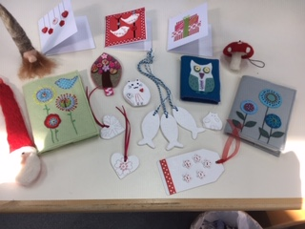

I was greatly saddened to hear of the closure of Denman College in the last week I have fond memories of Denman my first visit was with the Lancashire federation and my good friend Janet when we did Scandinavia crafts.

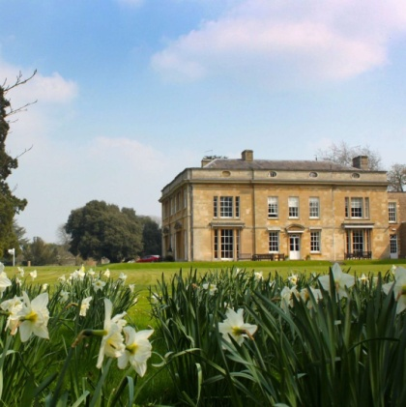
I was hooked by its charm, character and hospitality I have returned several times since and have enjoyed every visit as have many of us within this group. I was last there the last week before lockdown and it seems we were the last course to be at Denman. To think we won’t return to this lovely place saddens me but hopefully will return to our crafts groups very soon and I hope to have news by the next newsletter

Until then keep safe and keep smiling,
Kind regards Linda x

A FOND FAREWELL TO ROSEMARY SMITH

What a lovely photo of three happy ladies attending our Christmas Lunch at Fairhaven Golf Club on December 4th, 2019. Sadly in the New Year, Rosemary (pictured centre) became unwell after an operation and passed away on Monday 13th July.

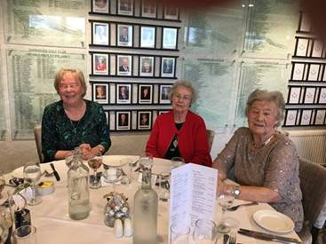
Evelyn, Rosemary, Barbara

She will missed by her friends and family and her W.I. family too. Rosemary had been a member with our W.I. since September 2010.

KNITTERS CAN YOU HELP?

The two charities above are appealing for
- toddler hats and scarves
- children’s cardigans or jumpers
- adults hats and scarves
- garter stitch squares, minimum 6” or larger either individual or stitched into blankets

They are for distributing in this country and abroad

If you need patterns or wool you are welcome to contact Pauline Johnson of Fairhaven Methodist church on 01253 789980, you can also contact her regarding passing on your completed items, (alternatively email me, Glenis, and I’ll arrange collection)

Thank you to Barbara Knowles who has brought this appeal to our attention.

The charities involved are international aid trust and knit for peace

(Eulogy from Barbara Dobson and Evelyn Davidson)

“Evelyn and I knew Rosemary for 50 years. What a lovely friend she was; always helpful; always the same and a joy to be with. She always put other people first and cared about her friends without making a fuss.

She had two sons, Peter and Ian who, with their families, loved and supported her.

She worked in the office at Trinity Hospice for many years and supported Action for Children and Lytham Lifeboat.

We both have many lovely memories of her and she will be greatly missed by all her many friends."

