ANSDELL & FAIRHAVEN W.I. NEWS
AUGUST 2021

AUGUST MEETING

Our W.I. ZOOM meeting is on Tuesday 10th August at 7.30pm. Our speaker is Lindsey Barrell on Burlesque, Me and the W.I.

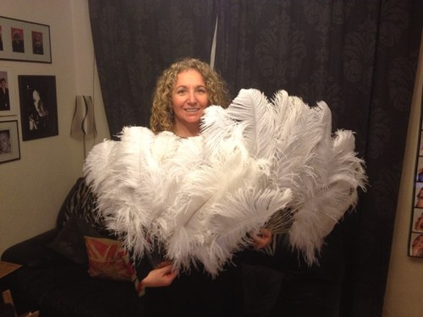

AUGUST EVENTS

Tuesday 3rd August @ 14.00 hours
Knit & Natter
Meeting @ Lowther Gardens

Tuesday 17th August @ 10.30 hours
Walking Group
Meeting @ Booths in Heyhouses Lane

Thursday 19th August @ 10.30 hours
Social Group
Meeting @ Lytham Hall

Tuesday 24th August @ 13.30 hours
Craft Group
Meeting @ St. Anne’s Parish Church Hall, Headroomgate Road, Lytham St. Anne’s FY8 3BA.
If you would like to attend this group, it is essential to email Linda Colclough to book a place as numbers are limited.

AUGUST BIRTHDAYS
Linda | Colclough
Jeanette | Preston
Anna | Webster
Patricia | McGauran
Eliena | Sagasti

Just a little reminder …

LANCASHIRE FEDERATION OF WOMEN’S INSTITUTES

TREASURE HUNT
1st September @ 6pm
Cock & Bottle Pub, 70 Church Road, Tarleton, PR4 6UP
Closing date 26 August

CENTENARY AFTERNOON TEA
12th – 15 September @ 2pm
Closing date 26 August

The Lowry (The Quays, Salford)
Sun 12th September

Woolton Golf Club
Mon 13th September

Barton Grange Hotel
Tue 14th September

Mitton Hall
Wed 15th September

£18.00 per person

HOW TO USE FACEBOOK GUIDE
VIA ZOOM
26th August @ 10am
OR
09th September @ 7pm

Further details on all the above will be advertised on the federation website www.lancashirewi.org.uk

Full instructions on how to book and pay are available on the Website under ‘Useful forms and Info’

HOW TO BOOK/PAY FOR
A COURSE OR EVENT ONLINE

Open up on your Internet Browser the LFWI Webpage with www.lancashirewi.org.uk

Along the top of the screen, you will see a tab ‘book LFWI events’. Click on the event you want to book, adding the quantity and click add to cart. Check what you have booked and how many then Click on checkout. To pay through a PayPal account, click on PayPal and follow the instructions.

YOU DO NOT HAVE TO PAY BY THIS METHOD, you can pay using a credit or debit card. Enter email address in customer information, tick box for permissions. Fill in billing address and press continue. Check billing address.

Payment – press checkout which takes you to another screen, scroll down to pay by credit or with debit card. This takes you to another screen where you enter your card number, expiry date, security code (3 digits on back)
Check billing address is same as your bank account is registered to and put in contact information, mobile and email address.

YOU DO NOT HAVE TO CREATE A PAYPAL ACCOUNT. Scroll to the bottom of the page and tick NO, I DON’T WANT AN ACCOUNT NOW. Tick box for terms and privacy statement (reading them first).

Click Pay now. This goes to another page that says THANK YOU and gives an order number. There is a download file icon that gives details of your zoom link or details, for you to save on your computer. You will need these to log onto either a zoom event or you will need the details to join an event. You will get a confirmation email from LFWI and an email to confirm your payment.

Dear Members,
We need your support to ensure that the A&FWI will continue after the next subscription date.
One thing we have learnt from other Committees we have served on and from other W.I’s, is that it is not helpful to any organisation to have the same people filling the Committee roles for an indefinite period. New ideas, new perspectives and fresh enthusiasm are the things that make a Committee successful.
All three officer roles will become vacant at the end of this subscription year and if A&FWI is to continue, we need to identify and train up our successors.
The three officer roles, which are mandatory for the running of a W.I, are President, Secretary and Treasurer. In addition, our Committee consists of a social secretary, a speaker secretary, MCS database support, Facebook and Website administrator and Refreshments support.
If you have concerns about the amount of time and effort involved, there is always an option to share a role. Conventionally only full members can serve on a Committee but there is the option, with Federation support, for dual members to serve too.
To ensure that A&FWI will continue beyond March 2022, please consider stepping forward to show your interest now. The outgoing members will be in a position to help and mentor the new role holders and we shall be in a strong position going forward into next year.

Kind regards,
Anne, Barbara, Dianne, Janet, Julie, Susan
Ansdell & Fairhaven W.I. Committee

