**ANSDELL & FAIRHAVEN W.I. NEWS**

**APRIL 2021**

**www.ansdellwi.weebly.com**

**A MESSAGE FROM THE PRESIDENT**

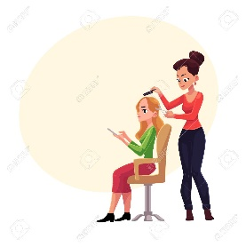Normality seems to be in sight at last - but I expect a lot of you are feeling uneasy about it all.  We're finally on the road to somewhere, with schools and shops opening and it won't be long before it will be legal to get a haircut!

 The odd thing is that we are not all jumping for joy at the prospect of a certain amount of freedom.  It is a bit weird that when we have been in our homes for so long, we're getting anxious about going back to "normal".  As hard as it has been in so many areas of our lives to be in lockdown, there is something strangely addictive to the simple life.  Only being able to get together with a few friends, removing the outside pressures to squeeze in as much as possible and simply not feeling guilty about reading a book, or watching a much loved film.

You're not alone if you are a little concerned about having to relearn some of our social skills.  Making small talk is an art that we have dispensed with for a while and it may be tough to stop talking about Covid as it has affected so many of us in so many different ways.

Perhaps another difficult transition is going to be getting "dressed up" rather than the comfortable leggings and slippers!!  Going back to normal - whatever normal is going to be - is worrying but at the end of this journey there is a destination we all deserve.  So let's get strapped in and enjoy the ride as much as we can, together!

Stay safe and serene,



**MEMBERSHIP**

Thank you to all of you who have already renewed your membership, please can anyone who has not done so as yet get their subscription to Dianne as soon as possible. As you know the cost this year is £34 for a full member and £11.60 for a dual member.



**APRIL MEETING**

Our April Zoom meeting is on Tuesday 13th April **at our usual time of 7.30pm.**

Our speaker is Philip Heaton who is going to talk to us about that fascinating subject, Astrology, I am sure this is going to be of interest to both the believers and non-believers amongst us! So do please use the link that Susan sends you “tune in” in time for a prompt start at 7.30pm.

**APRIL BIRTHDAYS**

Happy Birthday to our two April babies, we all hope you have a lovely day – and delicious cake.

Julie Boulton

Diana Wilson



Dorothy Barret tells us

about Snow Angels

###### I never think about “Angels” without thinking of my children making snow angels when we went skiing.

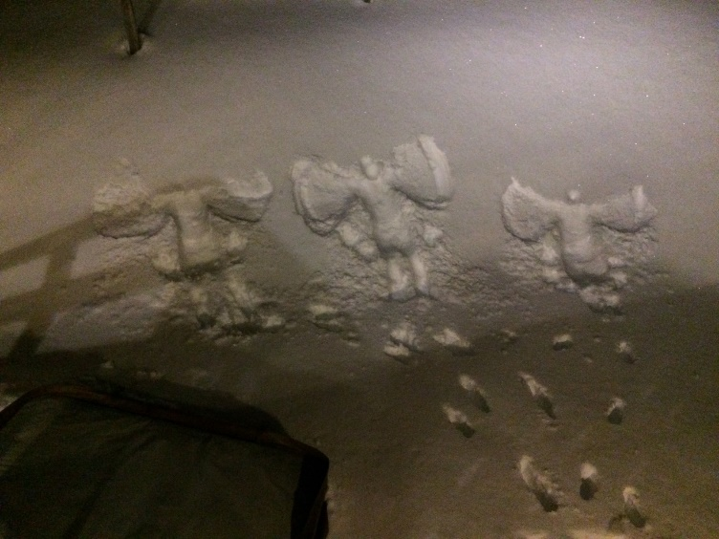

They produced these snow angels after jumping out of a hot tub!

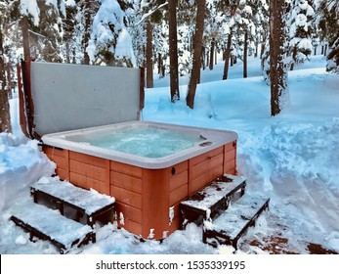



Glenis knows some WI Angels

At the beginning of January last year I found myself in the position of having to go to the GP’s surgery every day for two weeks for an injection. This would be difficult at any time, but as some of you may remember at that time I was in a lot of pain, couldn’t drive and couldn’t walk more than a few paces! So not only did I need a lift to the surgery, but also needed to be taken in by wheelchair to the nurse’s area on the first floor.

How was I going to manage this with the only family who could help either working or living 75 miles away?

Who came to my aid? - I’m sure you have guessed. A&FWI of course!

A group of committee and members was organised for me. On their allotted day each person collected me by car, took me to the surgery, went inside to borrow the Practice’s wheelchair, came back out with it, loaded me up and wheeled me inside and up in the lift to the nurse – then took me home! What a wonderful group of angels, I could not have managed without them! 

I was, and am, so very grateful for the help they and others have given me.

**What do Angels Look Like?**

Like the little old woman who returned your lost purse yesterday

Like the stranger who pointed the way when you were lost

Like the friend who touched your heart when you didn’t think you had one to touch

Angels come in all sizes and shapes, all ages and skin types and colours

Some with freckles, some with dimples, some with wrinkles and some none.

They come disguised as friends, strangers, nurses, teaches, students, lovers and fools

They are hard to find when your eyes are closed,

But they are everywhere when you look and you choose to see!

**Or are they like this one drawn by Dianne David’s very talented husband?**

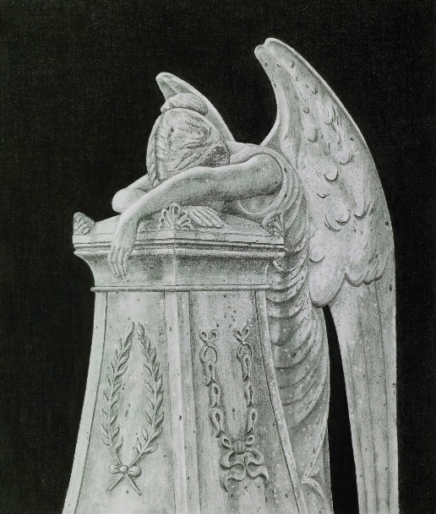

This is his superb pencil drawing of a statue in St Anne’s Parish Church graveyard, entitled The Weeping Angel. Statues such as this were often erected in Victorian and Edwardian times in memory of their loved ones, this one belongs to a family named Brightmore.

Does anyone know anything about them?

**Perhaps Linda Colclough has the answer…**

… as she tells us about her encounters with angels!

I have always been slightly psychic as my grandmother was a medium I’m not particularly religious but I do believe in angels. Whenever I am in a bad place or worried about myself or someone else I always pray to my angels and somehow things turn out right

There are angels for all kinds of things for instance love, health, abundance, guidance, healing, marriage etc. Then there are archangels who help you with the greater difficulties in life, like the loss of a loved one, patience, faith, peace etc.

The angels have to be called upon to help you as they cannot act alone; so if you need help with anxiety, health or you just want to keep someone safe during this pandemic ask an “angel of light “ to help you and see if it works for you - HAVE FAITH

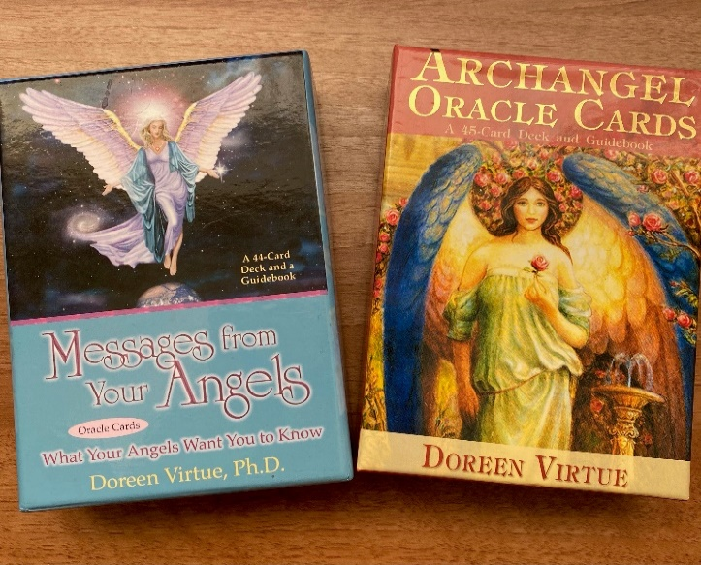

I have angel cards from which I do readings they give me guidance and if I’m to pray for you I will ask my angels to help you.

-------------------------------------------------------------

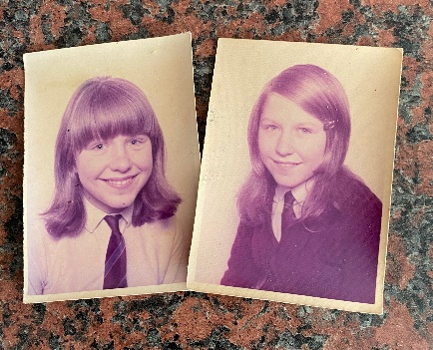Here’s a young Linda, with an angelic smile, - in her school uniform to introduce our next theme ----

SCHOOL DAY MEMORIES

Dorothy Williamson sets us off on a very cheery note!

This photo was taken at my primary school pantomime Babes in the Wood, when I was principal boy – Prince Charming.

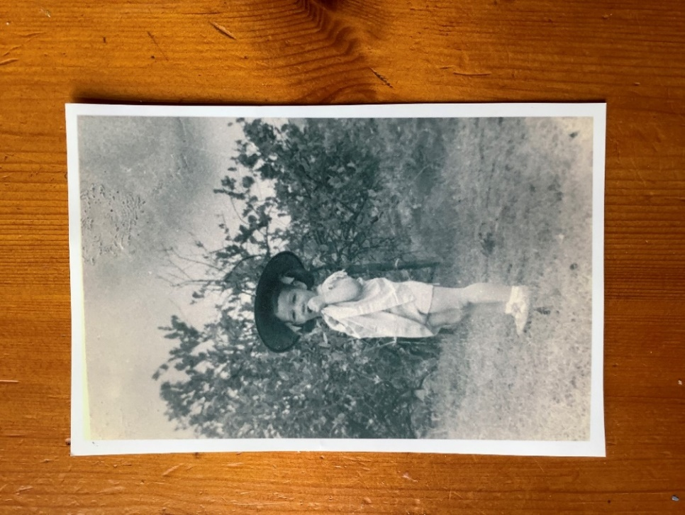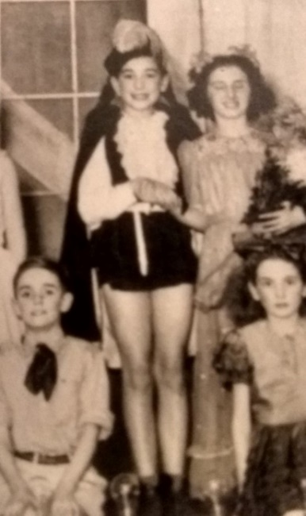

For this role one of the songs I performed was ‘Look for the Silver Lining’ and the lines below have stayed with me all my life.....

*Look for the silver lining whenever a cloud appears in the blue*

*Remember somewhere the sun is shining*

*And so the right thing to do is make it shine for you*

*A heart full of joy and gladness will always banish sadness and strife*

*So always look for the silver lining*

*And try to find the sunny side of life*

That’s certainly good advice today!!!

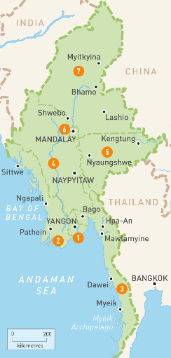Dorothy Barrett’s school days started 5000 miles away

I spent the first 5 years of my life and first year of schooling in rural Burma (now called Myanmar).

We didn’t wear school uniform but had to wear a coolie hat (not an acceptable term now!).

One of my earliest memories is being on a train during the annual water festival (to encourage the monsoon rain) when the carriage door was pulled open and buckets of water were thrown over us.  It felt very scary.

Susan Brierley has several photos which will provoke memories in us all

This photo is of some of my fellow pupils dressing up but no idea what we’re supposed to be or why?

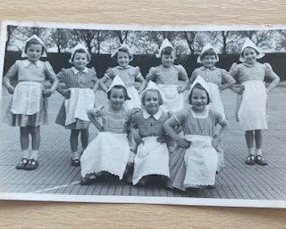

Taken mid 1950’s at Werneth Junior School in Oldham.

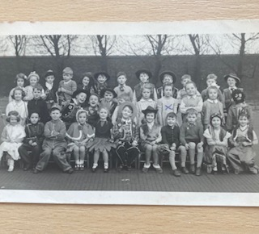

Here we are again dressing up - note no political correctness in those days!

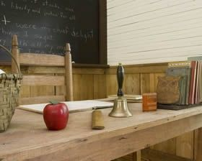

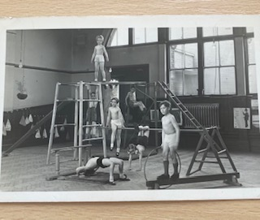

Gym day - anyone else remember doing PE in their knickers?

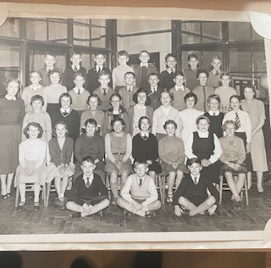

Final year 1959 with teacher and head mistress - note 37 pupils & all but one pupil passed their 11 plus exam to grammar school- what a commendation for Miss Mayhew!

Rita Calvert went to school by bike from the age of 5!

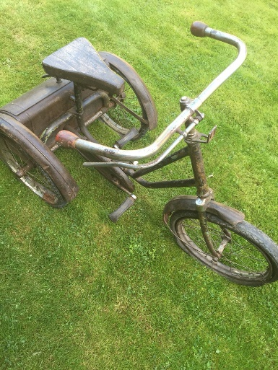I was brought up on a farm not far from the Giants Causeway in Northern Ireland. My primary school was a small two teacher one and it was a mile and a half from the farm. At the age of five I used to cycle to school on a large grey tricycle.

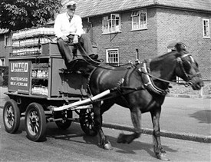

The milkman used to laugh when he saw me pedalling furiously trying to keep up with my three older siblings.



Joan Shaw’s School May Day memories

When I started school in the early 50’s our small village school was only just emerging from Victorian times.  The main event of the school calendar was May Day which was held around the middle of the month and to which parents and ‘very important’ people were invited.

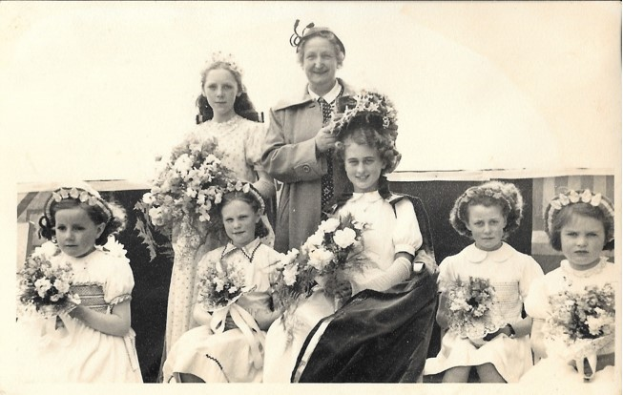

It was a pageant with a procession of the whole school, the crowning of the May Queen and country dancing.  The photo shows the event in 1953, Coronation Year and I’m the one scowling in the bottom right. Our very strict teacher drilled us all to be step perfect.  We were naïve, country children mainly from the farms around and not everyone enjoyed it!  I loved it all, the music, the dresses, the flowers and the dancing.  I remember bringing armfuls of bluebells to school on the day to decorate the scenery.

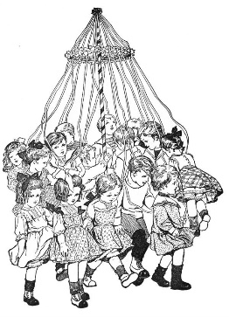Best of all was the maypole dancing; eight pairs of girls and boys, honour your partner, perfectly performed dances making intricate patterns with the ribbons.  I could still do the dances today – single and double plait, The Spider’s Web, The Gypsies’ Tent.

I wonder if anyone else has similar memories.

Joyce Hunt has a memory of a very proud mum!

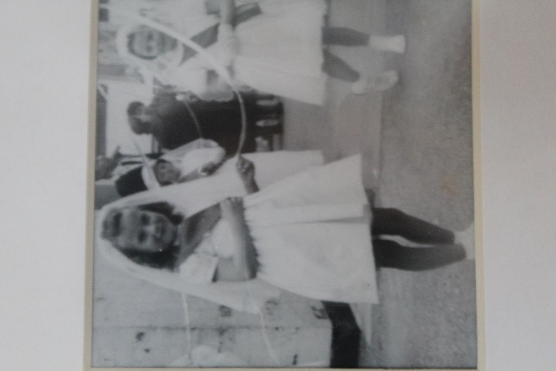

My first photo is of our junior school May Day Procession

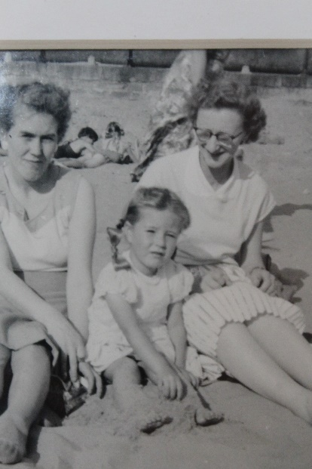

and my second   is on the beach with my mum on left of me and a great aunt on my right.

 I loved swimming, in my school days I would go to Lytham Baths every weekend. At school, St Bedes, I was picked to enter the School Competition against other local schools. I was to do Back Stroke also to dive from the top diving board!

My mum and dad never came to much at school as dad worked on the railways and mum had 2 jobs and 4 children, but this time mum came to see me. She hadn’t known that I could dive off the top board and afterwards she told me that, as I did so, her heart nearly came out of her chest with fear, but also adding it was a very proud moment for her.

That made my day, it is such a lovely school memory.

** LFWI Online events**

**April 2021**

**Lindsey Barrell (Mindfulness)**

Thursday 1st April - 7pm

**Alex Connell (Vegetarian Cooking)**

Tuesday 6th April - 7pm

**Gillian Walnes-Perry (Afternoon Tea)**

Wednesday 7th April - 7pm

**Clare Pooley (Best-selling author)**

Thursday 8th April, 7pm

**Ken Pye (Spooky Liverpool)**

Saturday 10th April – 2pm

**Al Sylvester (Walk to Freedom)** –

Monday 12th April – 7pm

**Helen Neave (Make in Wild)** –

Wednesday 14th April – 7pm

**James Haddow (The Taxi Driver Poet)**

Thursday 15th April - 7pm

**David Allen (The Amazing Mr Dickens)**

Monday 19th April – 7pm

**John Pearson (Cheese Maker)**

Wednesday 21st April – 7pm

**Chris Duffin (Retired Prison Governor)**

Thursday 22nd April – 7pm

**Jaye Windmill (Monumental Britain)**

Saturday 24th April – 2pm

**Andy Thomas (Mysteries /Crop Circles)**

Monday 26th April – 7pm

**Lana Pearson (Self Massage)**

Wednesday 28th April – 7pm

**Sian Fox (Life as a Home Economist)**

Thursday 29th April – 2pm

Full details on all these online events will be available a week before each event on our Website and Facebook and will be emailed to all WI Officers. You will be able to book them on the online store at **www.lancashirewi.org.uk.**

**All events are priced at £5.00\***

**Please feel free to pass this information to friends and family as these events are open to non-members**

**Please note you do not need to have a PayPal Account to make the purchase, just follow the instructions on the payment page.**