**ANSDELL & FAIRHAVEN W.I. NEWS**

**April 2020**

**www.ansdellwi.weebly.com**

**APRIL AND MAY MEETINGS**



As you already know there will be no meetings or groups in April and as you’ve no doubt worked out we now have to cancel them and our speaker for May. We are hoping that we can book the speaker, Jacqueline Iddon, for another date.

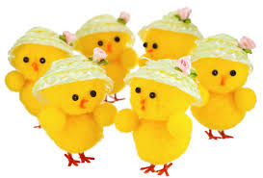**EASTER LUNCH**

Many of us were really looking forward to our Easter Lunch at Tiggi’s on Monday April 6th. Unfortunately, as you know, this cannot now go ahead. We hope to be able to rearrange the lunch for the summer, if you have already paid and cannot make the new date you will be reimbursed.

**APRIL BIRTHDAYS**

We wish our April birthday ladies a very happy birthday and hope you find a way to “see” family and friends!

**Margaret Imrie**

**Diana Wilson**

**Julie Boulton**

Thank-you for supporting Dianne’s book sale, both by donating and buying books. Perhaps if we’d known what was to come we would all have bought more!

The amount raised was £54 and this will be donated to Trinity Hospice later in the year

**SOCIALISE WHILST ISOLATED!!!**

We are all going to really miss our meetings, our groups and especially each other, so we have revamped the newsletter to try to help us keep in touch with you and help you keep you in touch with each other. We want it to be a Virtual Hug!

**CAN YOU MAKE US SMILE?**

It would be good to get input from members, perhaps you have a funny picture/caption such as the picture Tracey sent to one of our committee.

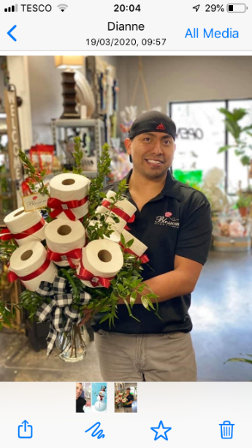*Would you rather have had this for Mothers’ Day than the flowers you actually got?*

**PAT SAYS SHE’D RATHER HAVE THE DELIVERYMAN!**

**CAN YOU SUGGEST IDEAS FOR OTHERS?**

Anything you would like to circulate to members would be welcome here, for example

How to volunteer to help others –

Try the trusted website - laughlivelove.org.uk who operate in Lytham and St Anne’s.

Useful local delivery sources –

Wool from Magic Loop 07902 541976

OR Bizzie Fingers 01253 721721

Vegetables from Strong’s 01253 735088

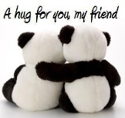**SO PLEASE EMAIL ME WITH YOUR INPUT** - glenis.taylor@outlook.com, ideally I’d like it by the middle of the month so please do try to send something - you’ll be giving your friends a virtual hug!

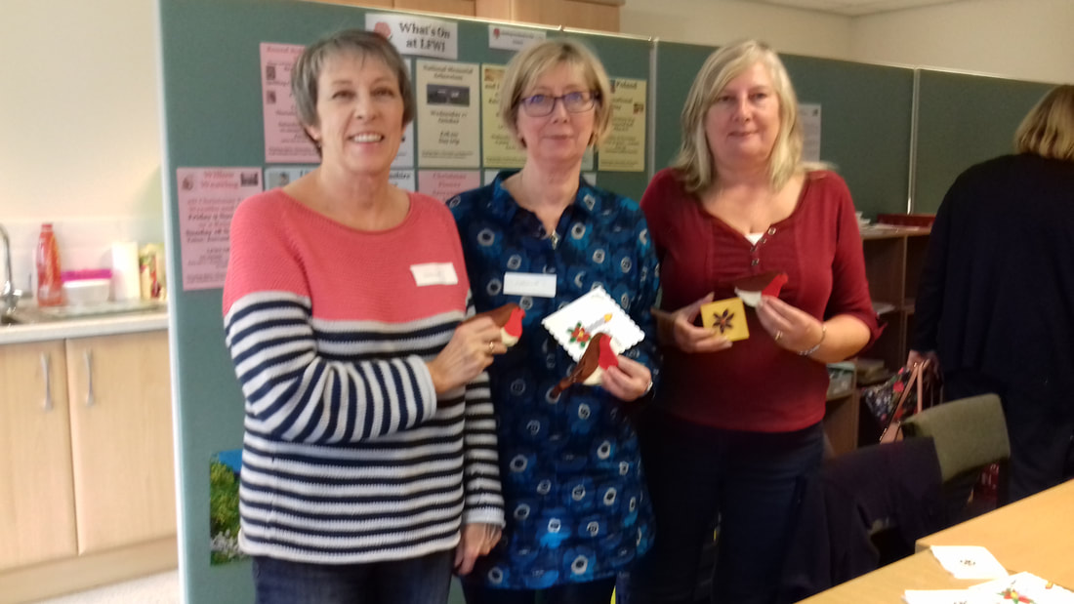**MAUREEN** -

**KNIT AND NATTER**

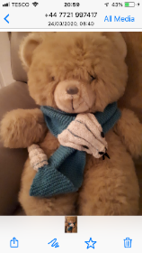If you now have some spare time why not knit a child’s scarf for our County Show, any pattern any size.

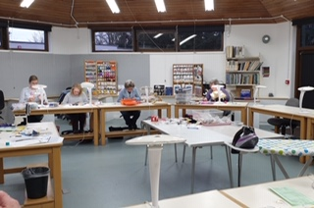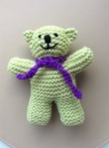If that’s not enough to keep you busy then look on our website ansdellwi.weebly.com; you’ll find lots of patterns you might try for tiny teddies, twiddlemuffs, baby hats and cardigans.

Or you could try [www.ravelry.com](http://www.ravelry.com); [www.lovecrafts.com](http://www.lovecrafts.com) or [www.pinterest.co.uk](http://www.pinterest.co.uk)  
You have to register on the sites but, if you put free in your search for patterns, it doesn't cost anything!  If anyone has any good projects to try please let us know.

Keep Knitting! Maureen x

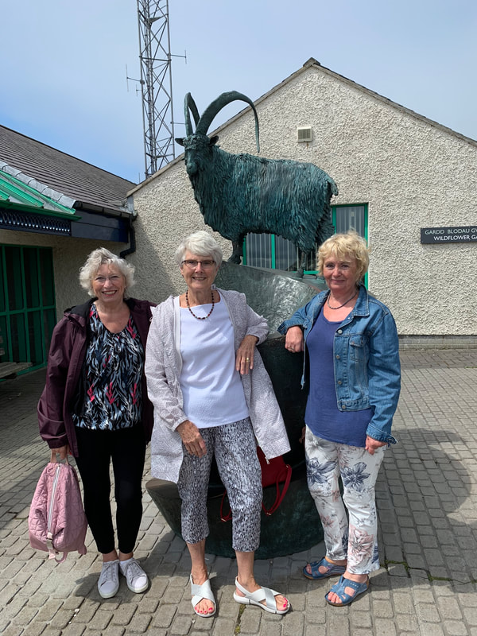

**VAL - BOOK CLUB**

“Dear Mrs Bird” by A.J. Pearce Hurray a thinner book, but packed with pathos, friendship, heartbreak and heroism. It has reminders of my childhood – use of correct English, emphasis on stiff upper lip, use of language “spiffing”, “the most exciting day ever”, “galoshes” etc.

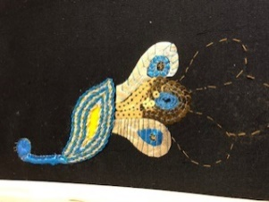

The story is one of female friendship between Emmeline and Bunty, the men in their lives and the ravages of WW2 and how it affected their lives. It is centred on Emmy’s desire to become a War Correspondent but she misconstrues an advertised vacancy and ends up as a typist for the “problem page” on Woman’s Weekly!

I hope you enjoyed it as much as I did, it demonstrates the indomitable desire of humans to survive the ravages of war which has echoes of our current situation with lockdown due to the virus!

Our next book is The Bookseller of Kabul, it’s about Afghanistan, its war, Taliban, and the effect on the lives of its people, especially women.

It’s a hard read, written by Asne Seierstad who spent 4 months in Afghanistan and as a war correspondent in Russia, ‘China, Kosovo, Iraq and Kabul.

Be safe and hope we all can meet soon. Val x

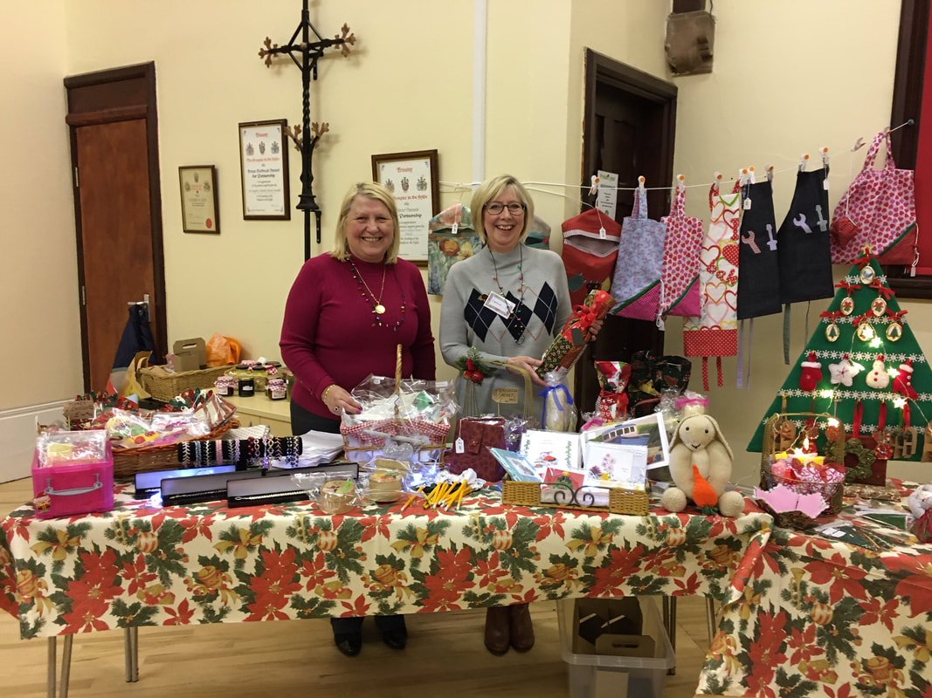**LINDA - CRAFT GROUP**

Hello lovely crafty ladies I hope you are all keeping safe and well and away from this nasty virus.

I had to come back from Denman a little earlier than planned but it was an enjoyable few days as we and one other group of 3 were all that were there we had the whole of Denman to ourselves, the food was still up to standard and the staff were brilliant we still had our shortbread biscuits with our morning coffee and cake with our afternoon tea. The catering staff really looked after us.

So what did I do well I did the Goldwork course which was a peacock 🦚 not my favourite bird but I knuckled down and had a go. Unfortunately I didn’t get it finished there so I’ve bought it home to finish.

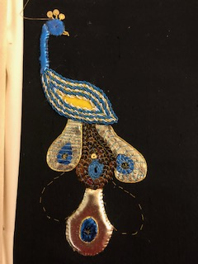 I’ve enclosed some photos for you to see and when it’s completed and we are back to normal I will bring it to show you all.

I am hoping to get a kit together with email instructions for those who want to do the dream catcher I can only drop it off when it’s safe to do so but it will give me something to do

In the meantime please finish your Lancashire rose.

Kind regards and stay safe, Linda x

**We hope when you read this you will feel our WI wrapping around you like a virtual hug, but - we are also part of a county network**

**BEING PART OF LANCASHIRE WI**

The Lancashire Federation website has a section on helping each other where members share ideas, stories, and photographs about how

Just log on to <https://lancashirewi.org.uk/> and scroll down to “Helping Each Other” and you’ll find a range of articles which you access by clicking the left and right arrows to find articles such as “Sunny Monday Thoughts”, “Making History” etc.

**(Message from Lancashire Federation - most courses for the coming months are being rescheduled if you can’t make the new date you will be reimbursed.)**

**… and part of a national network**

**BEING PART OF NATIONAL WI**

On the MyWI. Website you’ll find lots of factual information about the National Federation and advice about such things as running meetings etc. But… if you click on the “Make, Create and Do” section there’s lots to interest all

# The basics of flower arranging

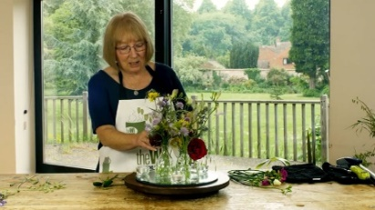If you’ve always wanted to give flower arranging a go or simply want to brush up on your skills, this series will help you get started. If flower arranging isn’t your thing there’s cookery, crafts, gardening, culture and science, sport and well-being.

**TO ACCESS THE SITE**

* Log on to <https://mywi.thewi.org.uk/>
* Scroll down to the bottom of the page and enter your email address, then click on the “Register” button
* You will then get help with setting up your account

**OVER TO YOU**

We want you to give virtual hugs to each other – how? By sending a message via this newsletter next month. It can be showing everyone what you have been doing or telling us a funny story – real or imagined!

Pat is starting us off with both – she’s been rediscovering her talent in **Encaustic painting!** I had to look it up on the internet to find out what it is; it involves using heated beeswax to which coloured pigments are added. The liquid or paste is then applied to a surface, and below is what she has produced – Wow what a talent!

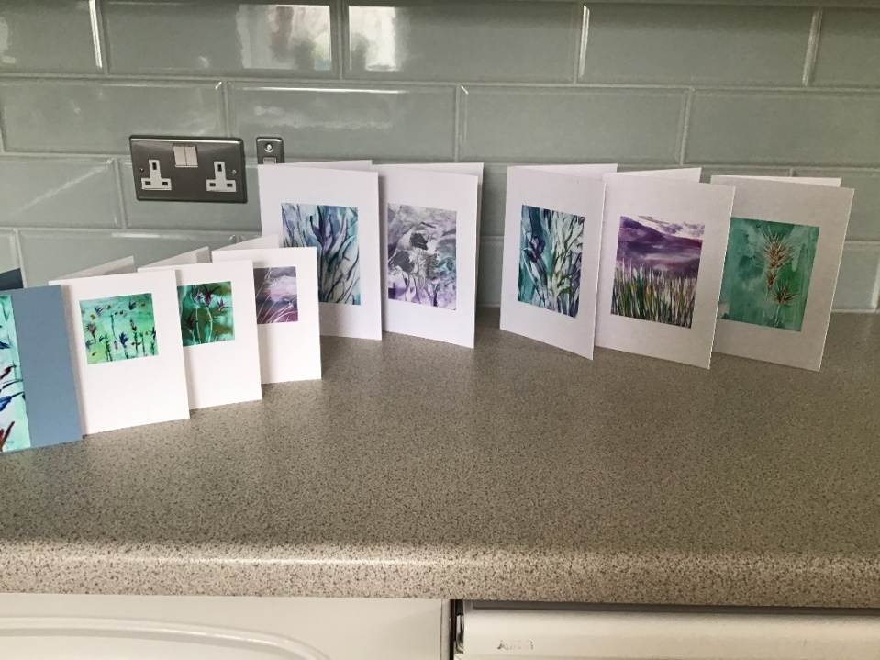

**Pat’s funny story**

“Taking the opportunity to catch up on mending, which was long overdue, I shortened the sleeves on my down winter coat. I wasn’t thinking and cut off the bottom of one sleeve, to then be totally covered in

DOWN! It was all over my black trousers, it floated all around my newly cleaned room. It was everywhere and just from just one sleeve.

The other sleeve I just turned up. I knew the method I should have used but I was taking a short cut, which turned out to be a long one!!!!!!!! I did laugh though especially as I had waited about 10 years, (not joking), to do this alteration! But at least it’s finally done and I think I’ve got rid of every feather now!”

**So make us laugh and give your friends a**

By sending your messages to me at

glenis.taylor@outlook.com